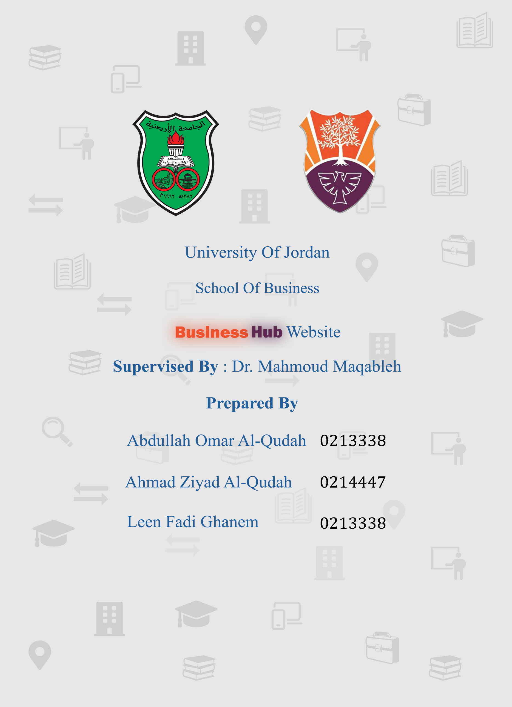 

University Of Jordan

School Of Business

Management Information Systems

Business Hub

Supervised By: Dr. Mahmoud Maqableh

Prepared By:

Ahmad Ziyad Al-Qudah (2212417)

Abdallah Omar Al-Qudah (0213338)

Leen Fadi Ghanem (0214447)

Submitted Date: 25/3/2025

Table of Contents

Abstract 4

1.Introduction 0

1.1 Background 0

1.2 Problem Statement (What, Where, How) 0

1.3 People Involved (Who) 0

1.4 Proposed Solution (Why, How) 1

1.5 Objectives 1

1.6 Target Users 1

2. Problem Definition 1

2.1 Problem Statement 2

2.2 Project Scope 2

2.3 Uniqueness and Innovation 2

2.4 Issues 3

3. Business model 3

3.1 Value Proposition 3

3.2 Target Customers and Market Segment 3

3.3 Key Activities 4

3.4 Key Resources 4

3.5 Customer Relationships 4

3.6 Distribution Channels 5

4. Revenue Model 5

4.1 Revenue Streams 5

4.2 Cost Structure 5

5. Feasibility studies 5

5.1 Technical Feasibility 6

5.1.1 Required Technologies 6

5.1.2 System Integration and Compatibility 7

5.2 Economic Feasibility 7

5.2.1 Cost Estimation 7

Expected Income After One Year (Google AdSense) 8

Expected Costs After One Year 9

Expected Profit Margin 9

5.3 Operational Feasibility 10

5.3.1 User Readiness and Adoption 10

5.3.2 Business Process Integration 10

5.3.3 System Maintenance and Support 10

6. Project Plan 11

6.1 Project Planning Phase (1 Week) 11

6.2 Design Phase (3 Weeks) 11

6.3 Development Phase (6 Weeks) 12

6.4 Testing Phase (2 Weeks) 12

6.5 Deployment Phase (1 Week) 13

6.6 Post-Deployment Phase (Ongoing) 13

7. Questionnaire 15

7.1 Survey Questions 15

7.2 Survey Results Summary 17

8. Use Case 19

2. Flowcharts 20

2.1 Student/Admin Login F.C 20

.1 2.2 Student Register F.C 21

.1 2.3 Book Exchange F.C 22

.1 2.4 Monitor Book Exchange F.C 23

.1 23

2.5 24

.1 2.6 Manage Department F.C 25

1. 3. Data Flow Diagram 26

3.1 Context-Level Diagram 26

3.2 Zero-Level Diagram 27

Child-Level Diagram 28

4. ER-Diagram 32

5. Data Dictionary 34

5.1 Users Table 34

5.2 Departments Table 34

5.3 Book exchange Table 34

5.4 Book offers Table 35

5.5 Book Requests Table 35

5.6 Chat Messages Table 35

5.7 Courses Table 36

5.8 Books Table (Static Materials) Table 36

5.9 Academic Staff Table 36

5.10 Notification Table 37

5.11 Entity Interactions Overview 37

6. Entity-Event Matrix 38

7. Mock Screens 39

# Abstract

The Business Hub platform is designed to enhance student life by providing a centralized system for book exchange, academic staff information, and campus navigation. Many students struggle to access course materials, locate faculty offices, and navigate the university efficiently. This project addresses these challenges by integrating essential academic services into a single, user-friendly platform.

The platform enables students to buy, sell, and trade books, access faculty contact details and office hours, and utilize an interactive campus map. Developed with React for the front end, Node.js for the back end, and MySQL for database management, it ensures smooth, scalable, and responsive experience.

A feasibility study confirms the project’s technical and financial viability, with low development costs and potential monetization through advertising and premium features. The structured development roadmap, including planning, design, implementation, and testing, guarantees a robust and efficient system.

By digitizing academic support services, the Business Hub improves accessibility, communication, and efficiency, making university life more organized and convenient for students, faculty, and administrators.

# 

# 1.Introduction

# 1.1 Background

This project operates within the educational technology domain, specifically focusing on student support services in higher education. In many universities, business students face a lack of centralized access to academic resources, departmental information, and campus guidance. The current reliance on scattered social media platforms, informal communication, and outdated systems creates confusion and inefficiencies. Our project addresses this gap by offering a unified digital platform that simplifies access to study materials, faculty information, campus navigation, and student guidance.

## 1.2 Problem Statement (What, Where, How)

* **What:** The business provides a platform that solves the issue of scattered student resources and unorganized access to academic services.
* **Where:** The business operates on an online website designed specifically to serve business students within the Faculty of Business.
* **How:** Students currently search for materials through social media groups, ask peers for staff locations, or rely on word of mouth to find campus info. These methods are unorganized, unreliable, and time-consuming. The business solves this by organizing all services in a clear structure categorized by majors and departments and making them accessible with just a few clicks through the website.

1.3 People Involved (Who)

The business owners are the three student developers who built and manage the platform. Employees include student volunteers from the Faculty of Business who help update information and materials when needed. The customers are regular students seeking easy access to academic resources and support.

## 1.4 Proposed Solution (Why, How)

* **Why:** The new system is needed to replace scattered, inefficient methods with a centralized, reliable platform. It adds value by saving time, reducing confusion, and providing organized access to essential services for business students.
* **How:** The proposed Business Hub platform will consolidate essential academic services, offering interactive multimedia for classroom navigation, structured book exchange systems, comprehensive staff directories, and detailed academic roadmaps tailored to each business major.

## 1.5 Objectives

* Provide business students with centralized access to academic resources, including course materials and a structured course tree by major.
* Simplify student life by gathering essential services such as hall locations, faculty contacts, university bus routes, and nearby support resources in one platform.
* Offer interactive tools and features like a book exchange, GPA calculator, and FAQ section to enhance academic support and engagement.
* Guide students through important academic transitions, especially graduation procedures, through a clear and accessible graduate guide.
* Promote student well-being and campus involvement by showcasing fun activities, unique campus spots, and underrated student-friendly services.

1.6 Target Users

Business students within the Faculty of Business, including regular users & volunteer

# 2. Problem Definition

## 2.1 Problem Statement

Business students often face difficulties accessing academic materials, locating faculty offices, and discovering important university resources due to the absence of a centralized platform. This creates a fragmented experience where students waste time, miss out on valuable services, and often spend more money than necessary. Without proper guidance, many navigate university life randomly, relying on scattered advice. This system aims to solve that by providing a well-organized, accessible website that gathers all essential services in one place—helping students save time, reduce costs, and enjoy a smoother, more informed academic journey.

## 2.2 Project Scope

The project aims to develop a web-based platform that centralizes all essential academic and campus-related services for business students. It will include features such as a structured course tree with downloadable materials, a book exchange system, academic staff information, hall locations, updated faculty news, guides for graduation procedures, tools like a GPA calculator, and access to nearby useful services. The system is designed to be easy to navigate and regularly updated with the help of student volunteers. The platform will cover almost every important need for business students, except for a missing item reporting feature, which is currently outside the project scope. The target audience includes all students within the Faculty of Business who seek organized, fast, and reliable access to the resources that support their academic journey.

## 2.3 Uniqueness and Innovation

What sets this system apart is its shift away from unreliable, scattered solutions like social media groups and word-of-mouth communication. Existing methods depend on slow approval processes, inconsistent responses, and the risk of outdated or inaccurate information. In contrast, our platform offers a structured, reliable, and instantly accessible source tailored specifically to business students. One of the most innovative features is the integrated book exchange section, which replaces the random, inefficient way students currently trade books. By allowing users to post, search, and connect directly through the platform, we eliminate the missed opportunities and confusion common in scattered Facebook posts. This system is not just a replacement it’s a smart upgrade that saves students time, improves accuracy, and creates a more seamless academic experience compared to traditional or informal alternatives.

## 2.4 Issues

While the system offers clear benefits, it may face certain challenges during and after launch. One potential issue is resistance from individuals who are hesitant about change or innovation, and may discourage others through negative word of mouth rather than supporting the platform's growth. Additionally, language barriers could affect usability for some students; however, this has been addressed by providing a fully translated Arabic version of the site to ensure accessibility for all users. Another concern is the possibility of minor technical issues or system downtime upon launch, especially during the early access phase. While such problems are typically easy to fix once reported, they may initially create a negative impression among users. Despite these challenges, the long-term value and convenience the platform brings to business students far outweigh the temporary obstacles.

# 3. Business model

## 3.1 Value Proposition

The system eliminates the confusion of scattered information by offering business students a centralized, reliable platform. It saves time, cuts frustration, and delivers organized, up-to-date content far more effective than social media or random advice.

## 3.2 Target Customers and Market Segment

The primary users of the system are business students at the University of Jordan, including those from all academic years and majors. The system serves the governmental educational institution JU Business School.

## 3.3 Key Activities

The main processes required to operate the system successfully include completing front-end and back-end development, integrating the platform with a functional database, creating a secure user login portal, and hosting the system on a public domain. Additionally, the platform will be promoted through faculty-related Facebook pages with a small marketing campaign to reach the target audience. Once launched, the system will function as a 24/7 accessible website, providing continuous support and resources for business students.

## 3.4 Key Resources

To develop and sustain the system, several key resources are required. On the technical side, we rely on our personal laptops and mobile phones for development and content creation, along with tools such as Visual Studio Code for coding, draw.io for designing page layouts, Microsoft Office for documentation, and Adobe Photoshop for icon editing. Human resources include the three student developers responsible for building the platform, and in the future, a team of up to 5 to 8 student volunteers may be needed to support maintenance, updates, and user feedback. Financial resources involve subscriptions to Microsoft Office and Adobe Photoshop, as well as domain hosting costs. While partnerships or third-party services are not essential for launch, we may propose future collaboration with the Deanship of Student Affairs to support hosting and funding the project.

## 3.5 Customer Relationships

The system will interact with users through a direct, self-service interface where students can easily access the information and tools they need without intermediaries Customer satisfaction will be maintained through regular content updates, responsive support from volunteers, and a user-friendly bilingual interface that adapts to students’ needs.

## 3.6 Distribution Channels

The system will reach customers through a publicly accessible website promoted via faculty Facebook pages and student groups. Users can access the service anytime through their web browsers on both computers and mobile devices.

# 4. Revenue Model

## 4.1 Revenue Streams

The main source of income for the system will come from displaying advertisements within the platform. By integrating ad space in a non-intrusive way, the system can generate ongoing revenue to help cover maintenance and hosting costs while keeping the service free and accessible for students.

## 4.2 Cost Structure

Development costs include software tools such as Visual Studio Code (free), Adobe Photoshop subscription (approx. $20/month), and Microsoft Office (around $10/month). Hosting and domain costs are estimated at $100/year for a reliable hosting plan and domain registration. Maintenance costs involve updates, security, and volunteer support, which could range around JD250, Marketing expenses include creating brochures within the faculty to be distributed among students, featuring a QR code for easy website access, which may cost around JD30 for printing and design. These costs

# 5. Feasibility studies

A feasibility study is an in-depth evaluation of a project's viability, analyzing its technical, financial, and operational aspects to support informed decision-making. It ensures that a project is practical, sustainable, and capable of addressing real needs before committing resources. In the case of **Business Hub**, this study assesses the platform’s potential to streamline academic resource access, book exchanges, and faculty support within the University of Jordan's Business School. By examining user demand, technical requirements, and implementation feasibility, we ensure the platform is both functional and impactful. This structured analysis helps validate its long-term sustainability, ensuring it effectively serves students while allowing for future growth.

## 5.1 Technical Feasibility

Technical feasibility evaluates the resources, tools, and technologies required to successfully implement the **Business Hub** platform. This includes software, development frameworks, and infrastructure necessary for deployment and maintenance. The key technical components for this system include:

5.1.1 Required Technologies

The system will be developed using HTML, JavaScript, and CSS for the front-end, with PHP for the back end. The platform will be web-based with a progressive web application (PWA) feature, allowing users to install the website on both Android and iOS devices

**Windows operating system** – Essential for development and testing.

**PHP MY ADMIN** – Used for backend development, providing a robust and scalable web.

**Frontend Technologies** – HTML, CSS, JavaScript for UI/UX, ensuring a responsive and dynamic interface.

**Microsoft Visual Studio Code** – The primary integrated development environment (IDE) for coding and debugging.

**Database Management** – PostgreSQL or MySQL for handling user data and system records.

**Draw.io** – Used for designing system architecture, wireframes, and workflow diagrams.

**Adobe Photoshop** – For editing and optimizing images and visual assets.

**Microsoft Word** – Used for documentation, report writing, and drafting content.

**Adobe Acrobat PDF Reader** – For managing and reviewing project documents and PDFs.

**Hardware**

* Dell – 12th Gen Core i7-12650H – 16GB RAM – 512GB SSD – 1TB HDD – NVIDIA RTX 3050Ti.
* HP – 11th Gen Core i5-1135G7 – 8GB RAM – 256GB SSD – 1TB HDD.
* Asus – Ryzen 5 5600H – 16GB RAM – 512GB SSD – Radeon Vega Graphic.

5.1.2 System Integration and Compatibility

The system will not integrate with any existing software or databases; instead, a custom database will be created to gather and manage all necessary information. As for compatibility, the system is fully compatible with most devices since it operates through web browsers, ensuring accessibility on both desktop and mobile devices without specific operating system dependencies.

## 5.2 Economic Feasibility

Economic feasibility evaluates the estimated costs required for the development, deployment, and maintenance of the **Business Hub** platform. The goal is to assess whether the project is financially viable and sustainable. Below is an estimated breakdown of the costs:

## 5.2.1 Cost Estimation

**1.** Software Costs**:**

Microsoft Office Suite – 250 JD

Adobe Photoshop – 300 JD (one-time license or annual subscription)

Draw.io (Free or Premium Version) – 50 JD (if premium is needed)

Adobe Acrobat PDF Reader – 80 JD

2. Hardware Costs:

Laptops (3 units for development team) – 700 JD * 3 = 2,100 JD

External Hard Drive (Backup & Storage) – 150 JD

3. Internet & Hosting Costs:

High-Speed Internet Connection – 200 JD/year

Domain Registration – 15 JD/year

Cloud Hosting (AWS/Google Cloud/Azure) – 30 JD/month = 360 JD/year

SSL Certificate (Let's Encrypt or Paid) – Free or 40 JD/year

Database Hosting (PostgreSQL/MySQL on Cloud) – 20 JD/month = 240 JD/year

4. Development & Miscellaneous Costs:

PHP (Open-source) – Free

Microsoft Visual Studio Code (IDE) – 25 JD/month = 300 JD/year

Marketing & Initial Promotion – 500 JD

Legal & Business Registration Fees – 300 JD

### **Expected Income After One Year (Google AdSense)**

|  |  |  |
| --- | --- | --- |
| Metric | Value | Notes |
| Estimated Daily Active Users | 150 | Active business students visiting the platform |
| Page Views per User per Day | 4 | Students browse around different pages |
| Total Daily Page Views | 600 | 150 users × 4 pages |
| CPM (Cost per 1000 Impressions) | $2.00 | Conservative AdSense estimate for educational content |
| Daily Ad Revenue | $1.20 | (600 ÷ 1000) × $2.00 |
| Monthly Ad Revenue | $36 | $1.20 × 30 days |
| **Annual Ad Revenue** | **$432** | $36 × 12 months |

### **Expected Costs After One Year**

|  |  |  |
| --- | --- | --- |
| Category | Cost (JD) | Notes |
| Microsoft Office Suite | 250 | Software cost |
| Adobe Photoshop | 300 | Software cost |
| Adobe Acrobat PDF Reader | 80 | Software cost |
| Draw.io Premium | 50 | Optional upgrade |
| Laptops for Dev Team (3) | 2,100 | Hardware for developers |
| External Hard Drive | 150 | Backup and storage |
| High-Speed Internet | 200 | Yearly plan |
| Domain Registration | 15 | Annual domain fee |
| Cloud Hosting (30×12) | 360 | Hosting servers |
| SSL Certificate | 40 | For HTTPS encryption |
| DB Hosting (20×12) | 240 | For MySQL/PostgreSQL |
| Visual Studio Code (25×12) | 300 | IDE usage (estimated as subscription) |
| Legal & Registration Fees | 300 | Business setup |
| **Total Annual Cost** | **4,885 JD** |  |

### **Expected Profit Margin**

|  |  |
| --- | --- |
| Metric | Amount |
| Annual Income (USD) | $432 |
| Annual Cost (JD) | 4,885 JD |
| Profit (Approx.) | **−4,580 JD** |
| Profit Margin | **Negative**  (Initial year loss due to setup and investment phase) |

## 5.3 Operational Feasibility

Operational feasibility assesses how well the **Business Hub** platform will function in a real-world environment, ensuring it effectively supports users and integrates seamlessly into academic processes.

5.3.1 User Readiness and Adoption

The system will be used primarily by students within the Faculty of Business. No formal training will be required, as the platform is designed to be intuitive and easy to navigate

5.3.2 Business Process Integration

The system will complement existing business processes by providing an organized, digital solution to access academic resources and services. It will replace manual processes such as searching for materials through social media or word of mouth, streamlining tasks like book exchanges, faculty contact lookups, and campus navigation into a single, efficient platform.

5.3.3 System Maintenance and Support

System updates and bug fixes will be handled through the "Contact Us" section, where users can report issues by directly emailing the developers. Once a problem is reported, it will be addressed promptly, ensuring ongoing technical support and timely resolution of any issues.

# 6. Project Plan

## 6.1 Project Planning Phase (1 Week)

Define Project Scope: Clarify features, user requirements, and project objectives.

Estimated Time: 1 day

Completion Date: Day 1

Team Formation and Resource Allocation: Assign roles to developers, designers, and other resources.

Estimated Time: 2 days

Completion Date: Day 3

Research and Selection of Tools and Technology: Decide on programming languages, frameworks, and APIs (e.g., React, Node.js, Google Maps).

Estimated Time: 3 days

Completion Date: Day 6

Create Detailed Project Schedule: Plan all future activities and assign deadlines.

Estimated Time: 1 day

Completion Date: Day 7

## 6.2 Design Phase (3 Weeks)

UI/UX Design: Develop wireframes and mockups for the platform.

Estimated Time: 1 week

Completion Date: End of Week 2

Platform Architecture Design: Design database schema, backend structure, and APIs.

Estimated Time: 1 week

Completion Date: End of Week 3

Review and Approval of Designs: Get feedback from stakeholders and make necessary revisions.

Estimated Time: 1 week

Completion Date: End of Week 3

## 6.3 Development Phase (6 Weeks)

**Frontend Development:**

Tasks: Develop website layout, book exchange system, staff directory, and campus map integration.

Estimated Time: 3 weeks

Completion Date: End of Week 6

**Backend Development:**

Tasks: Set up server, database, user management system,

Estimated Time: 3 weeks

Completion Date: End of Week 6

System Integration: Integrate frontend and backend, including API connections.

Estimated Time: 1 week

Completion Date: End of Week 7

## 6.4 Testing Phase (2 Weeks)

Unit Testing: Test individual components for functionality.

Estimated Time: 1 week

Completion Date: End of Week 8

Integration Testing: Test the integration of all components.

Estimated Time: 4 days

Completion Date: Day 4 of Week 9

User Acceptance Testing (UAT): Test with real users (students, faculty) for feedback.

Estimated Time: 3 days

Completion Date: End of Week 9

## 6.5 Deployment Phase (1 Week)

Prepare Hosting Environment: Set up cloud hosting services (AWS, Google Cloud, etc.).

Estimated Time: 2 days

Completion Date: Day 2 of Week 10

Deploy to Production: Upload the platform to the live environment and test deployment.

Estimated Time: 3 days

Completion Date: Day 5 of Week 10

Final Testing: Run final tests after deployment to ensure everything is working as expected.

Estimated Time: 2 days

Completion Date: End of Week 10

## 6.6 Post-Deployment Phase (Ongoing)

Monitoring & Bug Fixing: Address any issues or bugs identified by users.

Estimated Time: Ongoing

Completion Date: Ongoing, with regular updates as needed

User Training & Documentation: Create user guides and FAQs for students and staff.

Estimated Time: 1 week

Completion Date: Week 11

Collect User Feedback & Iterative Improvement: Collect feedback from initial users and iterate it on the platform to make improvements.

Estimated Time: Ongoing

Completion Date: Ongoing, with a major review every 3 months

High-Level Gantt Chart (For MS Project)

Here’s how to input this into MS Project:

Create tasks and assign start dates and end dates for each.

**Dependencies:** Some tasks depend on the completion of others (e.g., Frontend Development depends on Design completion).

**Resources:** Assign your team members to specific tasks, ensuring the right skills are applied where necessary.

Example Structure for **MS Project:**

|  |  |  |  |
| --- | --- | --- | --- |
| **Phase** | **Activities** | **Duration** | **Completion** |
| 1. Planning | Define project objectives, determine scope, resource allocation, preliminary feasibility analysis. | 1 week | 26 Feb - 4 Mar |
| 2. Analysis | Conduct detailed requirement gathering, system requirements analysis, feasibility studies (technical, economic, operational). | 2 weeks | 5 Mar - 18 Mar |
| 3. Design | Develop system architecture, UI/UX design, database schema design, create wireframes and mock-ups. | 3 weeks | 19 Mar - 8 Apr |
| 4. Development | Front-end coding (HTML, CSS, JS), back-end coding (PHP, MySQL), database integration, development of system components. | 5 weeks | 9 Apr - 13 May |
| 5. Testing | Unit testing, integration testing, system testing, user acceptance testing (UAT), and bug fixing. | 1 week | 14 May - 20 May |
| 6. Implementation (Deployment) | Preparation of hosting environment, deployment to production server, final system checks, and launch. | 1 week | 21 May - 27 May |
| 7. Maintenance | Ongoing monitoring, addressing issues, regular updates, user support, continuous improvement based on user feedback. | Ongoing | Ongoing |

Gantt Chart :

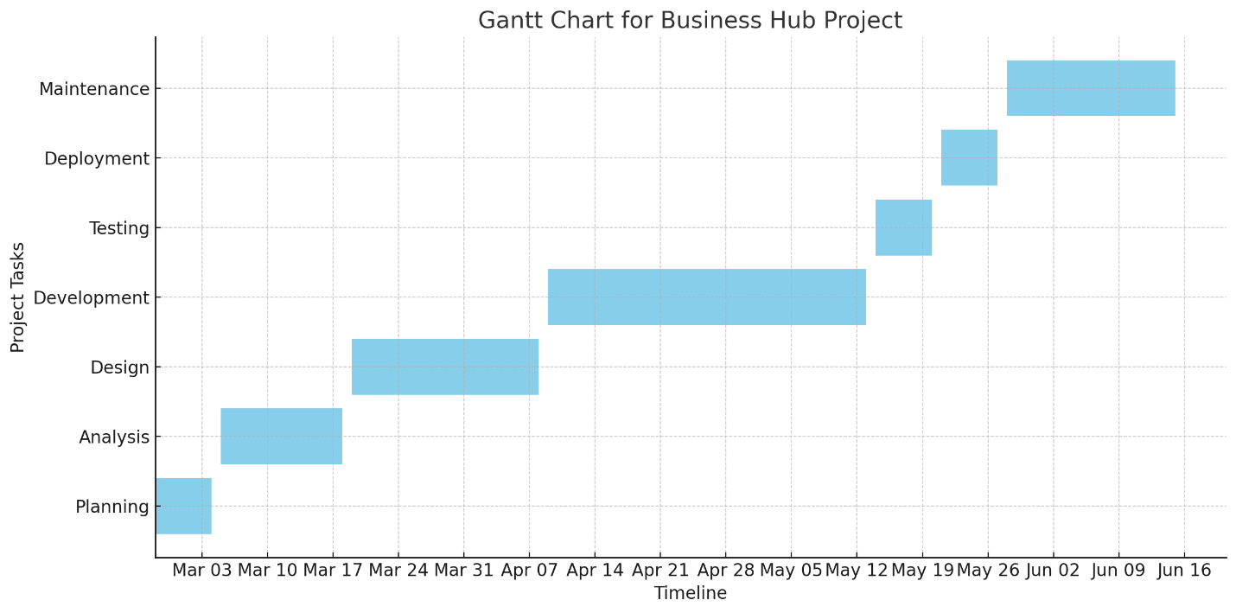

# 7. Questionnaire

This section presents a structured survey designed to collect key insights from students at the University of Jordan’s Business School. The questionnaire aims to evaluate the feasibility, usability, and necessity of the **Business Hub** platform by addressing common academic and administrative challenges faced by students.

## 7.1 Survey Questions

1. **Which year of study are you in?**
   * 1st year
   * 2nd year
   * 3rd year
   * 4th year
2. **Do you prefer to have a website for your faculty to help with your studies?**
   * Yes
   * No
   * Maybe
3. **Do you offer study materials to others?**
   * Yes
   * No
   * Occasionally
4. **Do you have difficulty enjoying your break time on campus?**
   * Yes
   * No
   * Sometimes
5. **Do you find it difficult to locate information about your major subjects in a simple form?**
   * Yes
   * No
   * Occasionally
6. **Are you experiencing difficulties when registering for courses?**
   * Yes
   * No
   * Sometimes
7. **Are you having trouble finding the right study resources for your courses?**
   * Yes
   * No
   * Occasionally

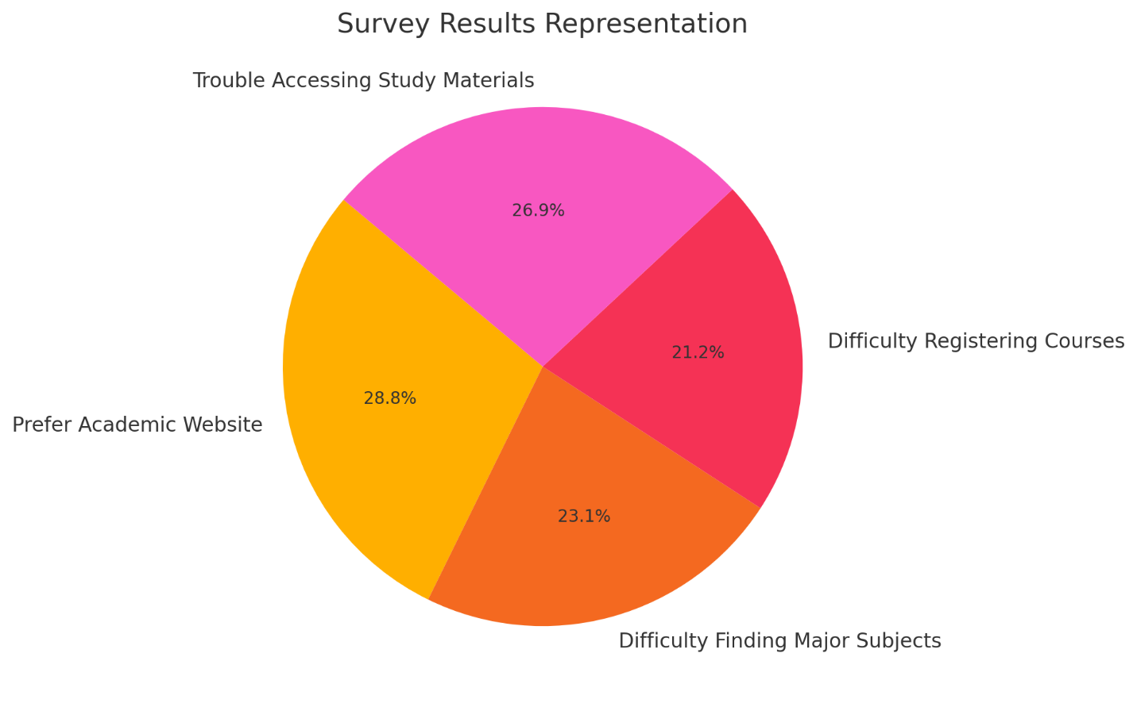

## 7.2 Survey Results Summary

A total of **[126]** students participated in the survey, and the responses were analyzed to determine the most critical student concerns. The results indicate:

**75%** of students prefer having an academic support website.

**60%** of students struggle with locating their major subjects' information.

**55%** of students experience difficulties in registering for courses.

**70%** find it challenging to access proper study materials.

# 8. Use Case

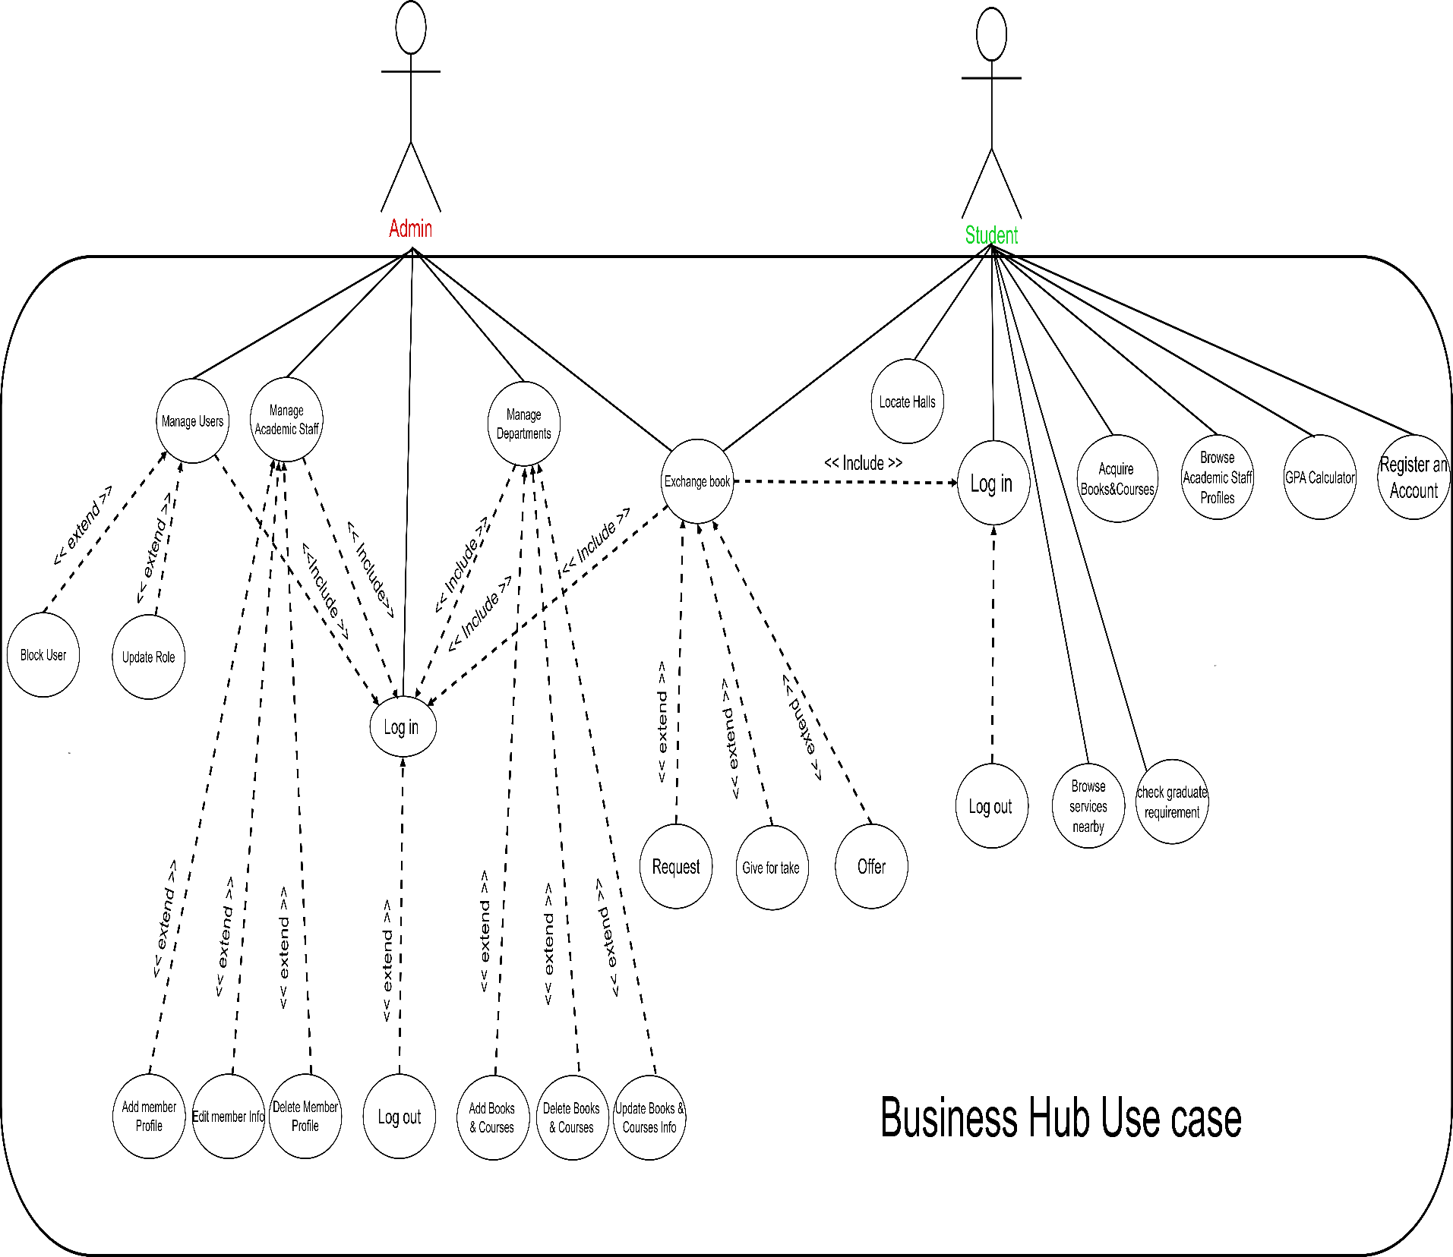A use case is a methodology used in system analysis to identify, clarify and organize system requirements. The use case is made up of a set of possible sequences of interactions between systems and users in a particular environment and related to a particular goal.

# 9.Flowcharts

A flowchart is a type of diagram that represents a workflow or process. A flowchart can also be defined as a diagrammatic representation of an algorithm, a step-by-step approach to solving a task.

## Student/Admin Login Flow Chart

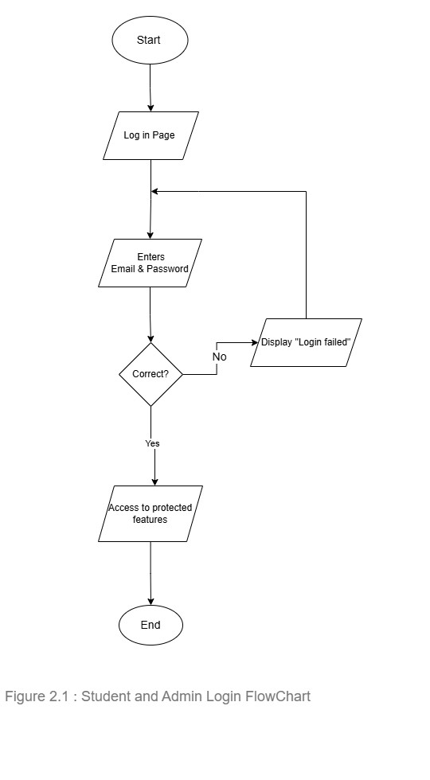

## 9.2 Student Register Flow Chart

## 9.3 Book Exchange F.C

## 2.4 Monitor Book ExchangeA black background with white rectangles AI-generated content may be incorrect. F.C

## 

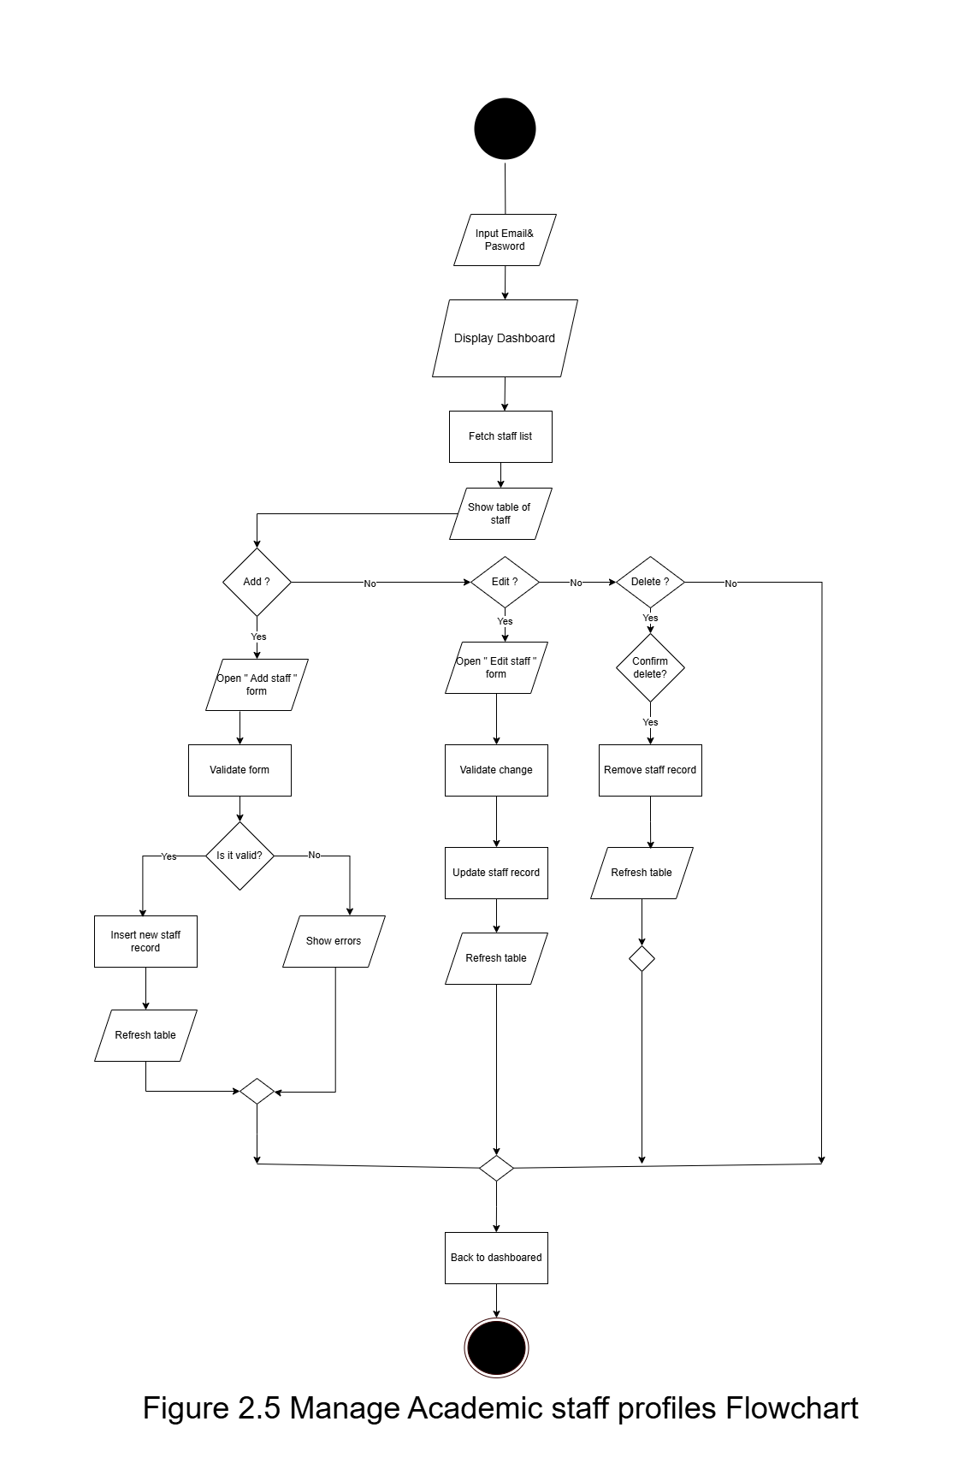2.5 Manage Academic Staff F.C

## A diagram of a diagram AI-generated content may be incorrect.2.6 Manage Department F.C

# 3. Data Flow Diagram

A data-flow diagram is a way of representing a flow of data through a process or a system. The DFD also provides information about the outputs and inputs of each entity and the process itself.

## Context-Level Diagram

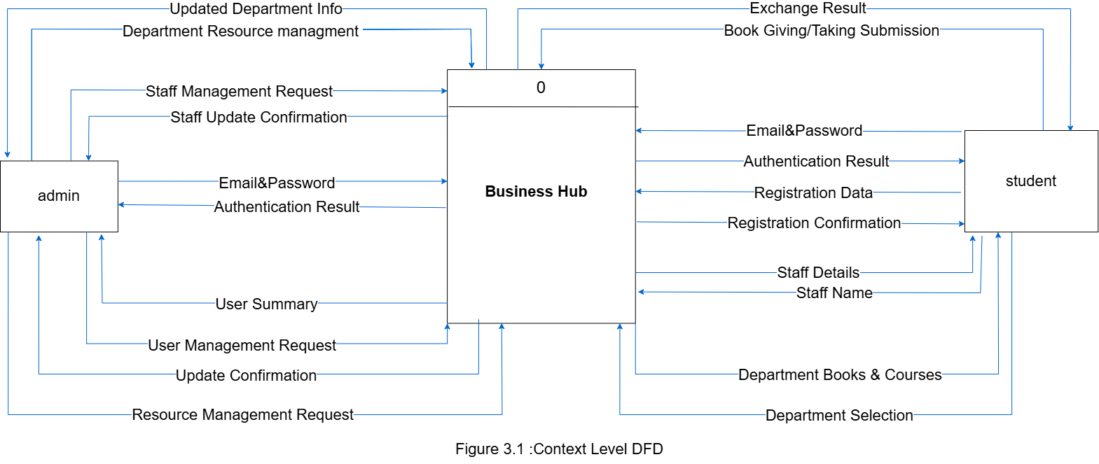

## Zero-Level Diagram

## 

## A screenshot of a computer screen AI-generated content may be incorrect.Child-Level Diagram

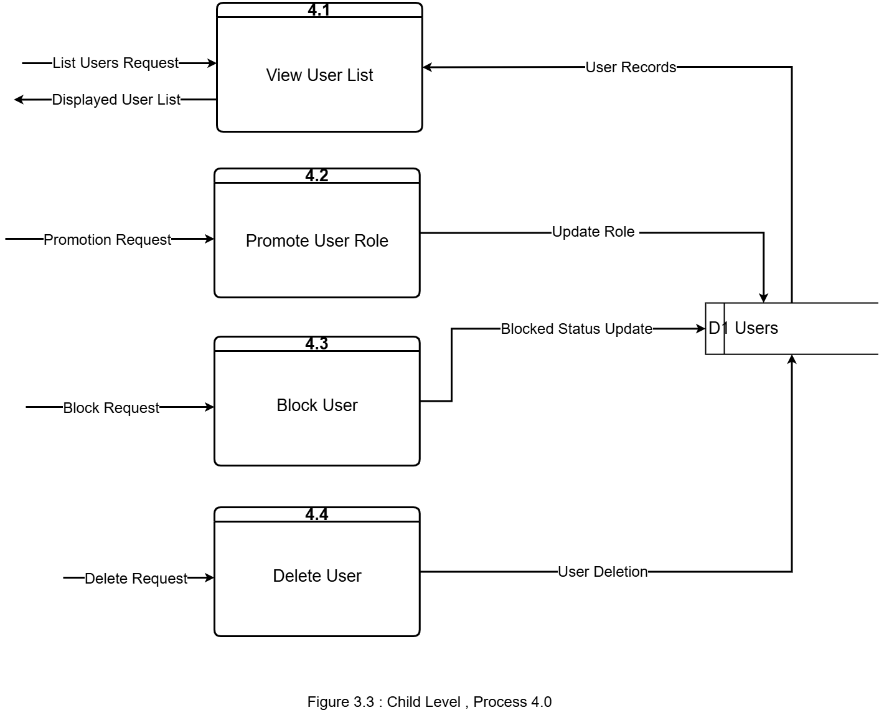

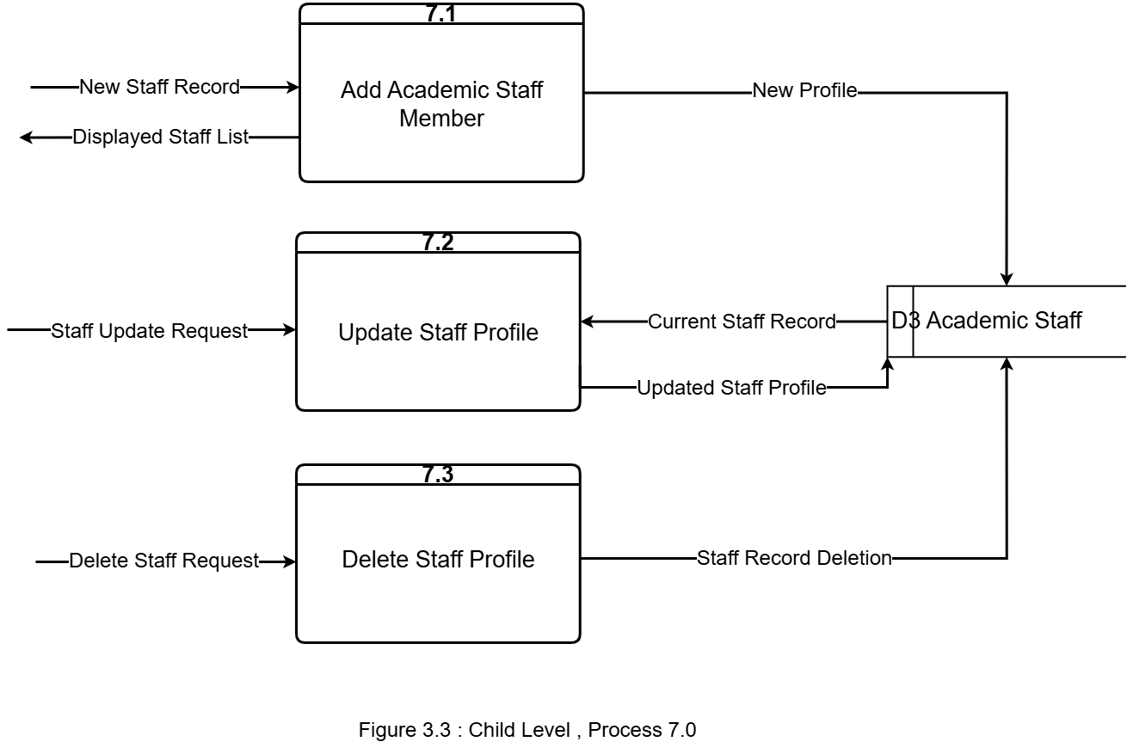

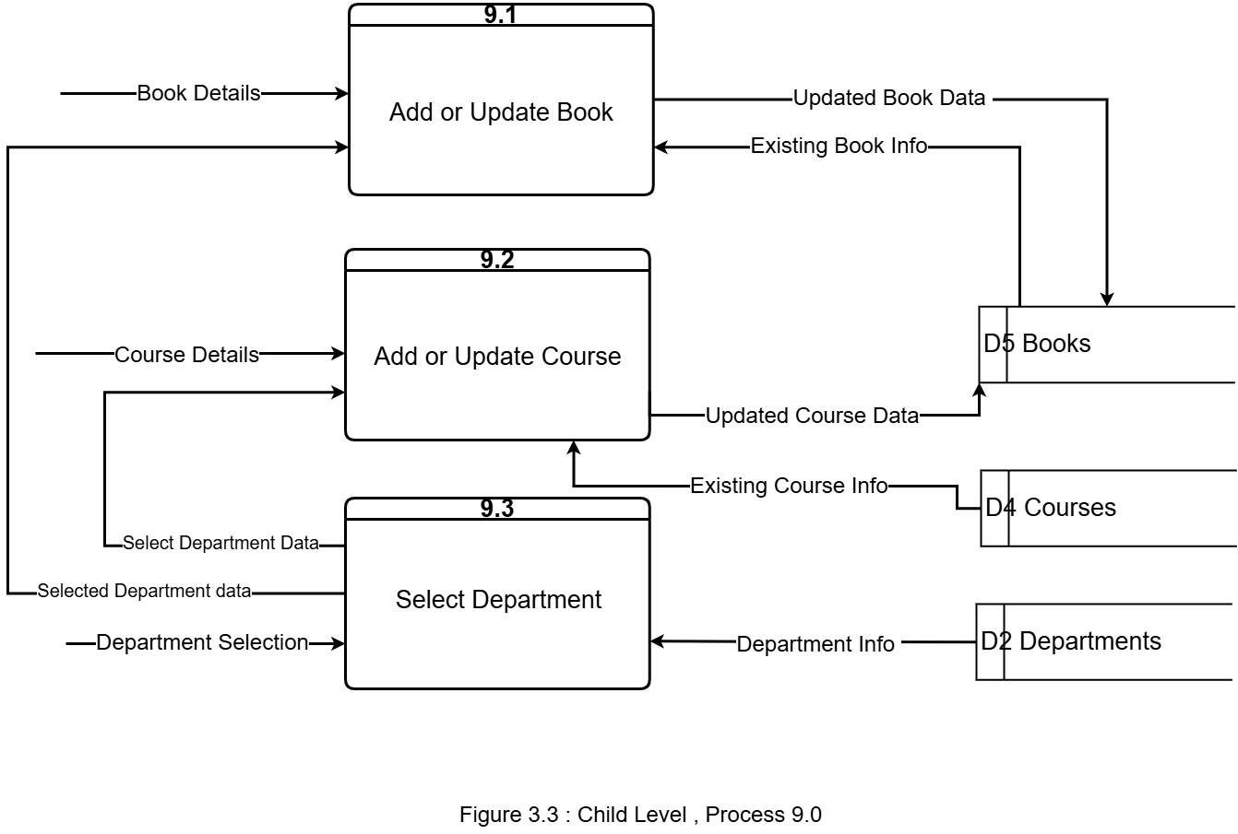

# 4. ER-Diagram

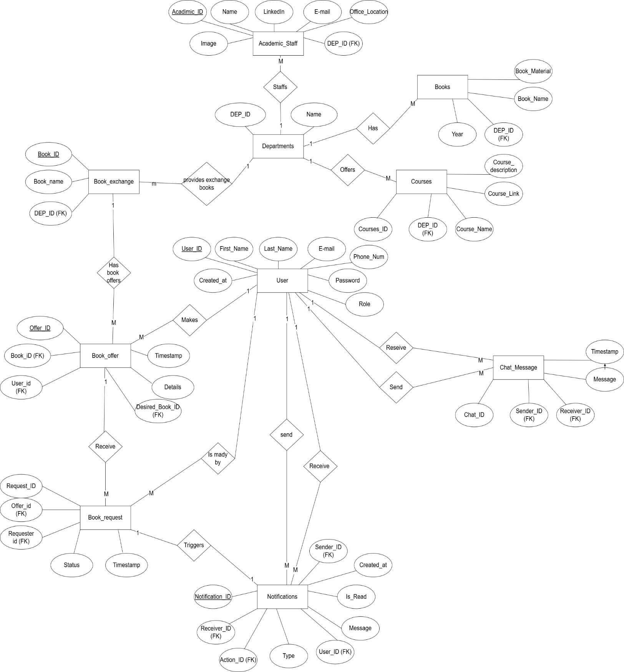

.

**Business Hub – Entity Relationship Diagram (ERD) Explanation**

This ER diagram represents the database structure for the Business Hub platform, designed to support book exchanges, academic resources, and student-staff interactions in a university setting.

Users**:** Stores all registered users (students or super admins). Each user has personal info like name, email, phone, and a role (user or super_admin) that controls their permissions.

Departments: Represents academic departments (e.g., MIS, Finance). It links to most academic content across the site.

Book_exchange: Lists all available books for exchange, categorized by department.

Book_offers: When a user clicks “Give” on a book, an offer is created and stored here. It includes optional details (e.g., book condition), and may include a desired_book_id if the user is using the "Give for Take" feature.

Book_requests: If another user clicks “Take,” a request is recorded here. It links to the original offer and tracks its status (pending, accepted, or rejected).

Notifications: Generated when a book request is made. This alerts the user who posted the offer and helps facilitate communication.

Chat_messages: Stores real-time messages exchanged between users once a book request has been accepted. This enables them to coordinate the physical exchange.

Courses: Contains downloadable/viewable course resources for each department (e.g., links, descriptions).

Books: Represents static learning materials uploaded for each department, available through department pages (not part of the exchange system).

Academic_staff: A directory of academic staff members, including their office location, university email, and LinkedIn profile. Each is assigned to a department.

# 5. Data Dictionary

A Data Dictionary is a collection of names, definitions, and attributes about data elements that are being used or captured in a database, information system, or part of a research project.

## 5.1 Users Table

|  |  |  |  |
| --- | --- | --- | --- |
| Column | Type | Description | Constraints |
| id | INT | Unique user identifier | PK  (Not Null) |
| first name | VARCHAR | User’s given name | (100) |
| last name | VARCHAR | User’s family name | (100) |
| email | VARCHAR | Login email (must be unique) | (255) Unique |
| phone | VARCHAR | 10‑digit phone number | (20) |
| password | VARCHAR | Hashed password | (255) |
| role | ENUM | Account type / permission level | ('user','super_admin') |
| created at | TIMESTAMP | Account creation timestamp | DEFAULT CURRENT_TIMESTAMP |

## 5.2 Departments Table

|  |  |  |  |
| --- | --- | --- | --- |
| Column | Type | Description | Constraints |
| id | INT | Unique department identifier | PK  (Not Null) |
| name | VARCHAR | Department name (e.g. “MIS”, “Finance”) | (100) |

## 5.3 Book exchange Table

|  |  |  |  |
| --- | --- | --- | --- |
| Column | Type | Description | Constraints |
| id | INT | Unique book listing identifier | PK  (Not Null) |
| book name | VARCHAR | Title of the book | (255) |
| department_id | INT | Which department this book belongs to | FK→ departments.id |

## 5.4 Book offers Table

|  |  |  |  |
| --- | --- | --- | --- |
| Column | Type | Description | Constraints |
| id | INT | Unique offer identifier | PK  (Not Null) |
| book_id | INT | The book being offered | FK→ book_exchange.id |
| user_id | INT | Who is offering the book | FK→ users.id |
| desired_book_id | INT | (Optional) Book they want in exchange (“Give‑for‑Take”) | FK → book_exchange.id |
| details | TEXT | Notes on book condition, extras, etc. |  |
| timestamp | DATETIME | When the offer was created | DEFAULT CURRENT_TIMESTAMP |

## 5.5 Book Requests Table

|  |  |  |  |
| --- | --- | --- | --- |
| Column | Type | Description | Constraints |
| id | INT | Unique request identifier | PK  (Not Null) |
| offer_id | INT | Which offer is being requested | FK→ book_offers.id |
| requester_id | INT | Who is requesting the book | FK→ users.id |
| status | ENUM | Current request state | ('pending','accepted','rejected') |
| timestamp | DATETIME | When the request was made | DEFAULT CURRENT_TIMESTAMP |

## 5.6 Chat Messages Table

|  |  |  |  |
| --- | --- | --- | --- |
| Column | Type | Description | Constraints |
| id | INT | Unique message identifier | PK  (Not Null) |
| sender_id | INT | Who sent the message | FK→ users.id |
| receiver_id | INT | Who receives the message | FK→ users.id |
| message | TEXT | The chat message content |  |
| timestamp | DATETIME | When the message was sent | DEFAULT CURRENT_TIMESTAMP |

## 5.7 Courses Table

|  |  |  |  |
| --- | --- | --- | --- |
| Column | Type | Description | Constraints |
| id | INT | Unique course identifier | PK  (Not Null) |
| department_id | INT | Which department offers this course | FK→ departments.id |
| course_name | VARCHAR | Course title | (255) |
| course_link | TEXT | URL or path to download/view course materials |  |
| course_description | TEXT | Summary or syllabus description |  |

## 5.8 Books Table (Static Materials) Table

|  |  |  |  |
| --- | --- | --- | --- |
| Column | Type | Description | Constraints |
| id | INT | Unique static‑book identifier | PK  (Not Null) |
| department_id | INT | Which department this resource belongs to | FK→ departments.id |
| book_name | VARCHAR | Title of the static learning material | (255) |
| book_material | TEXT | URL or path to the file |  |

## 5.9 Academic Staff Table

|  |  |  |  |
| --- | --- | --- | --- |
| Column | Type | Description | Constraints |
| id | INT | Unique staff member identifier | PK  (Not Null) |
| name | VARCHAR | Full name | (255) |
| email | VARCHAR | University email | (255) |
| linkedin | VARCHAR | Link to LinkedIn profile (optional) | (255) |
| image | TEXT | Path or URL to profile picture |  |
| office_location | VARCHAR | Office room or building (e.g., “Main 4th Floor”) | (255) |
| department_id | INT | Department the staff belongs to | FK→ departments.id |

## 5.10 Notification Table

|  |  |  |  |
| --- | --- | --- | --- |
| Column | Type | Description | Constraints |
| id | INT | Unique notification identifier | PK  (Not Null) |
| user_id | INT | Who triggered the notification (e.g. requester) | FK→ users.id (sender) |
| receiver_id | INT | Who should receive the notification | FK→ users.id |
| action_id | INT | What action this notification is about (link to request) | FK→ book_requests.id |
| type | VARCHAR | Notification category (e.g. “book_request”) | (100) |
| message | TEXT | Human‑readable notification text |  |
| is_read | BOOLEAN | Whether the notification has been seen by the receiver | DEFAULT FALSE |
| created_at | TIMESTAMP | When the notification was created | DEFAULT CURRENT_TIMESTAMP |

## 5.11 Entity Interactions Overview

After identifying and describing each table individually in the ER Dictionary, it is important to highlight how these entities are interconnected to form the core of the Business Hub system.

The *Users* table links to several other entities such as Book_Offers, *Book_Requests*, Notifications, and Chat_Messages, enabling students to exchange books, request materials, communicate with others, and receive system updates. The Departments table serves as a central hub connecting Academic_Staff, Books, and Courses, ensuring each major field of study is well-structured and its related academic resources are accessible.

Through the Book_Exchange, Book_Offers, and Book_Requests tables, the platform facilitates an organized, role-based book-sharing ecosystem. The Notifications table supports user interaction by alerting users to important events, while the Chat_Messages table enhances user experience through real-time communication.

# 6. Entity-Event Matrix

A CRUD matrix is a table showing the actions in an application containing SQL statement affecting parts of a database. CRUD Matrix is an excellent technique to identify the Tables in a Database to be used in any User interaction with a Web Site. CRUD means ‘Create, Read, Update or Delete’, and the CRUD Matrix identifies the Tables involved in any CRUD operation.

|  |  |  |  |  |  |  |  |  |  |  |  |
| --- | --- | --- | --- | --- | --- | --- | --- | --- | --- | --- | --- |
| Event / Entity | Users | Departments | Book Exge | Book Offers | | Book Requests | Notifications | Chat Messages | Courses | Books | Academic Staff |
| Register Account | **C** |  |  | |  |  |  |  |  |  |  |
| Log in | **R** |  |  | |  |  |  |  |  |  |  |
| Offer Book | **R** |  | **R** | | **C,R** |  |  |  |  |  |  |
| Request a Book | **R** |  | **R** | | **R** | **C,R** | **C** |  |  |  |  |
| Give for Take | **R** |  | **R** | | **C** |  |  |  |  |  |  |
| Browse Public Services | **R** | **R** |  | |  |  |  |  | **R** | **R** | **R** |
| Monitor Book Exchange | **R** |  | **R,U,D** | | **R,U,D** | **R,U,D** | **R** |  |  |  |  |
| Manage Academic Staff | **R,U,D** |  |  | |  |  |  |  |  |  | **C,R,U,D** |
| Manage Departments |  | **C,R,U,D** |  | |  |  |  |  | **C,R,U,D** | **C,R,U,D** |  |
| Manage Users | **R,U,D** |  |  | |  |  |  |  |  |  |  |
| Send Message | **R** |  |  | |  |  |  | **C,R,U,D** |  |  |  |
| Send Notification | **R** |  |  | |  |  | **C,R,U,D** |  |  |  |  |

# Mock Screens

Mock screens are visual drafts that show how a website or application’s pages will look and behave, helping to plan layout, design, and user flow before actual development.

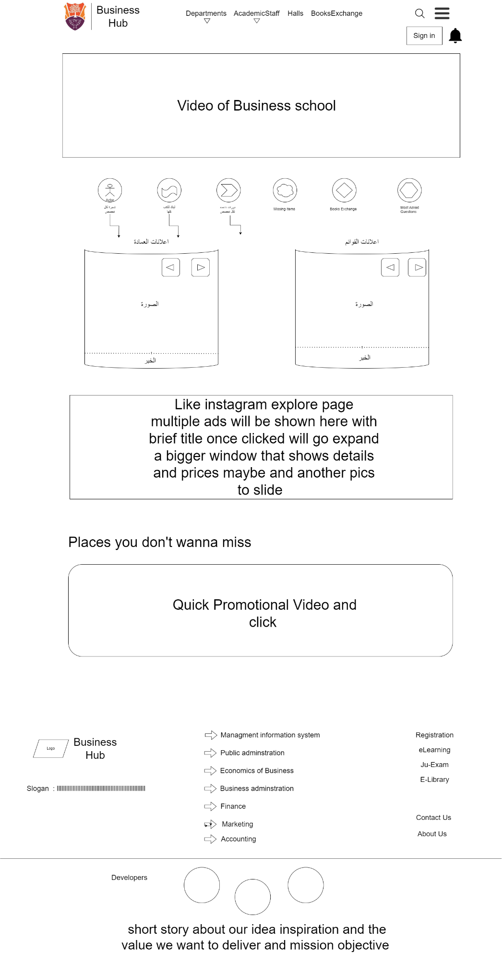

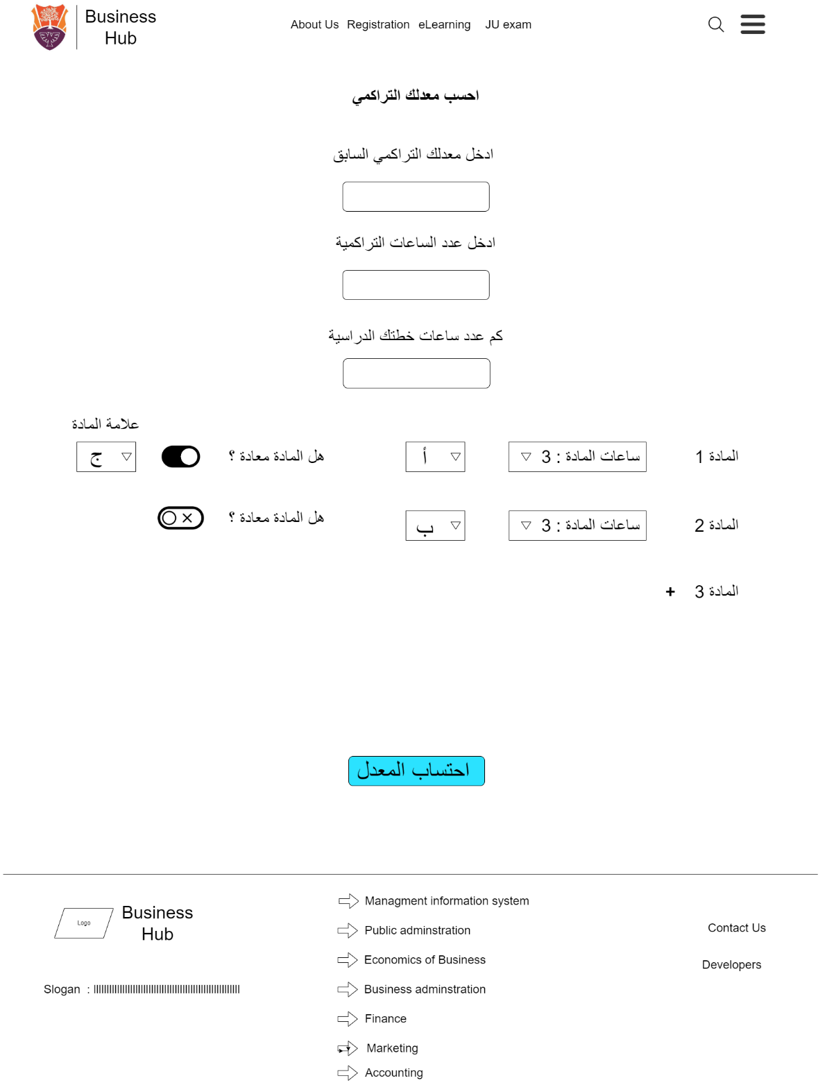

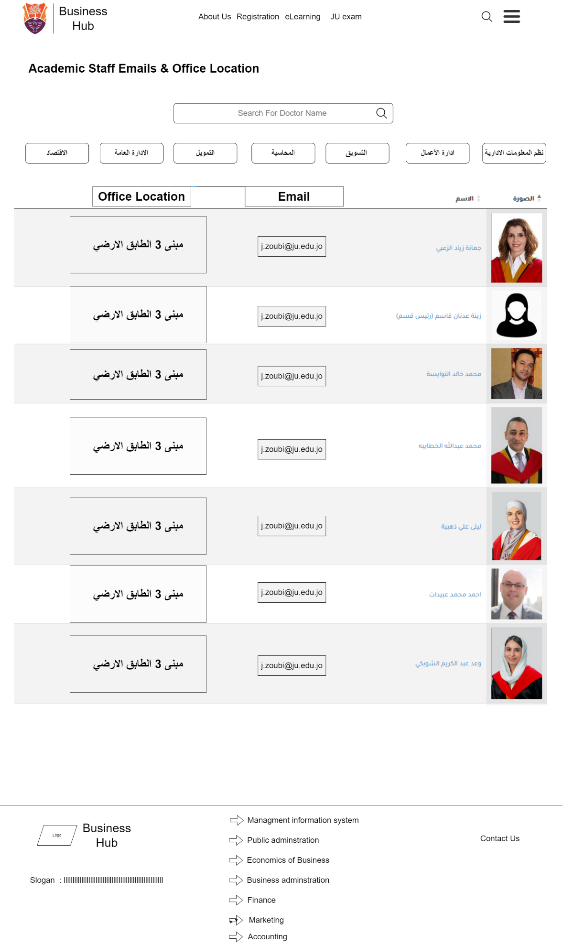

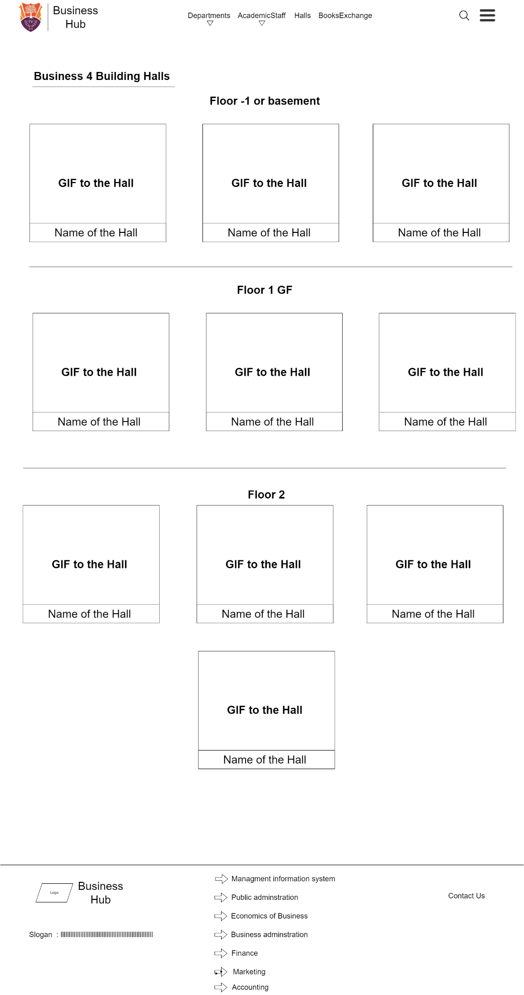

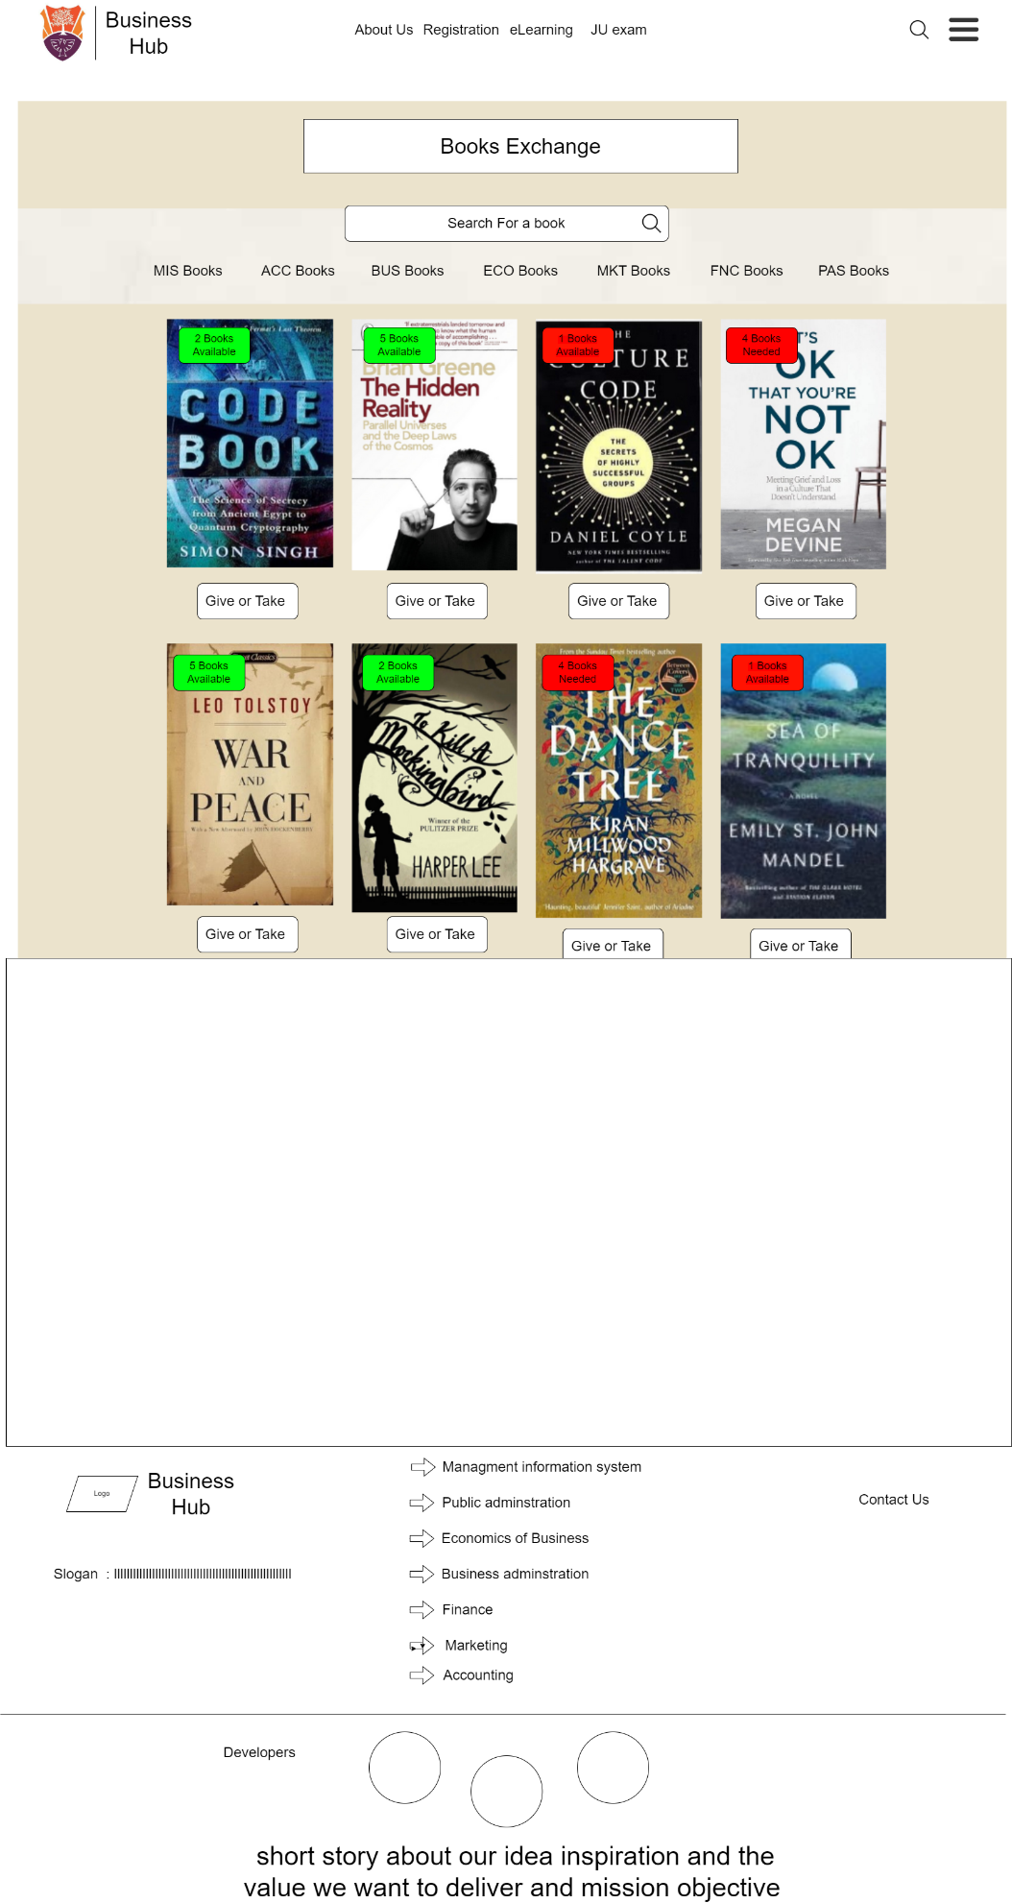

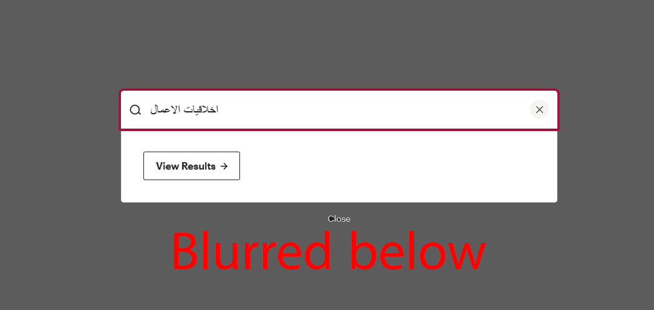



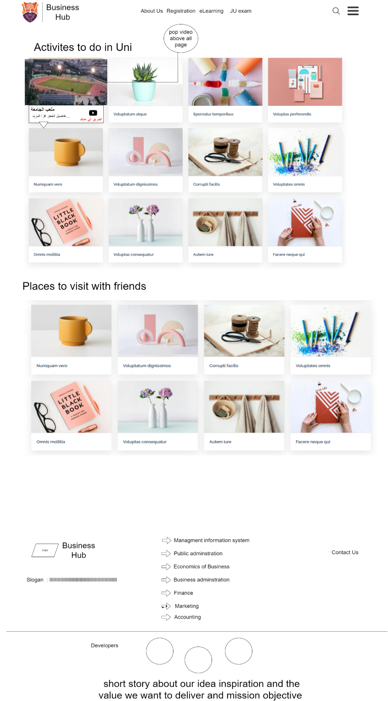

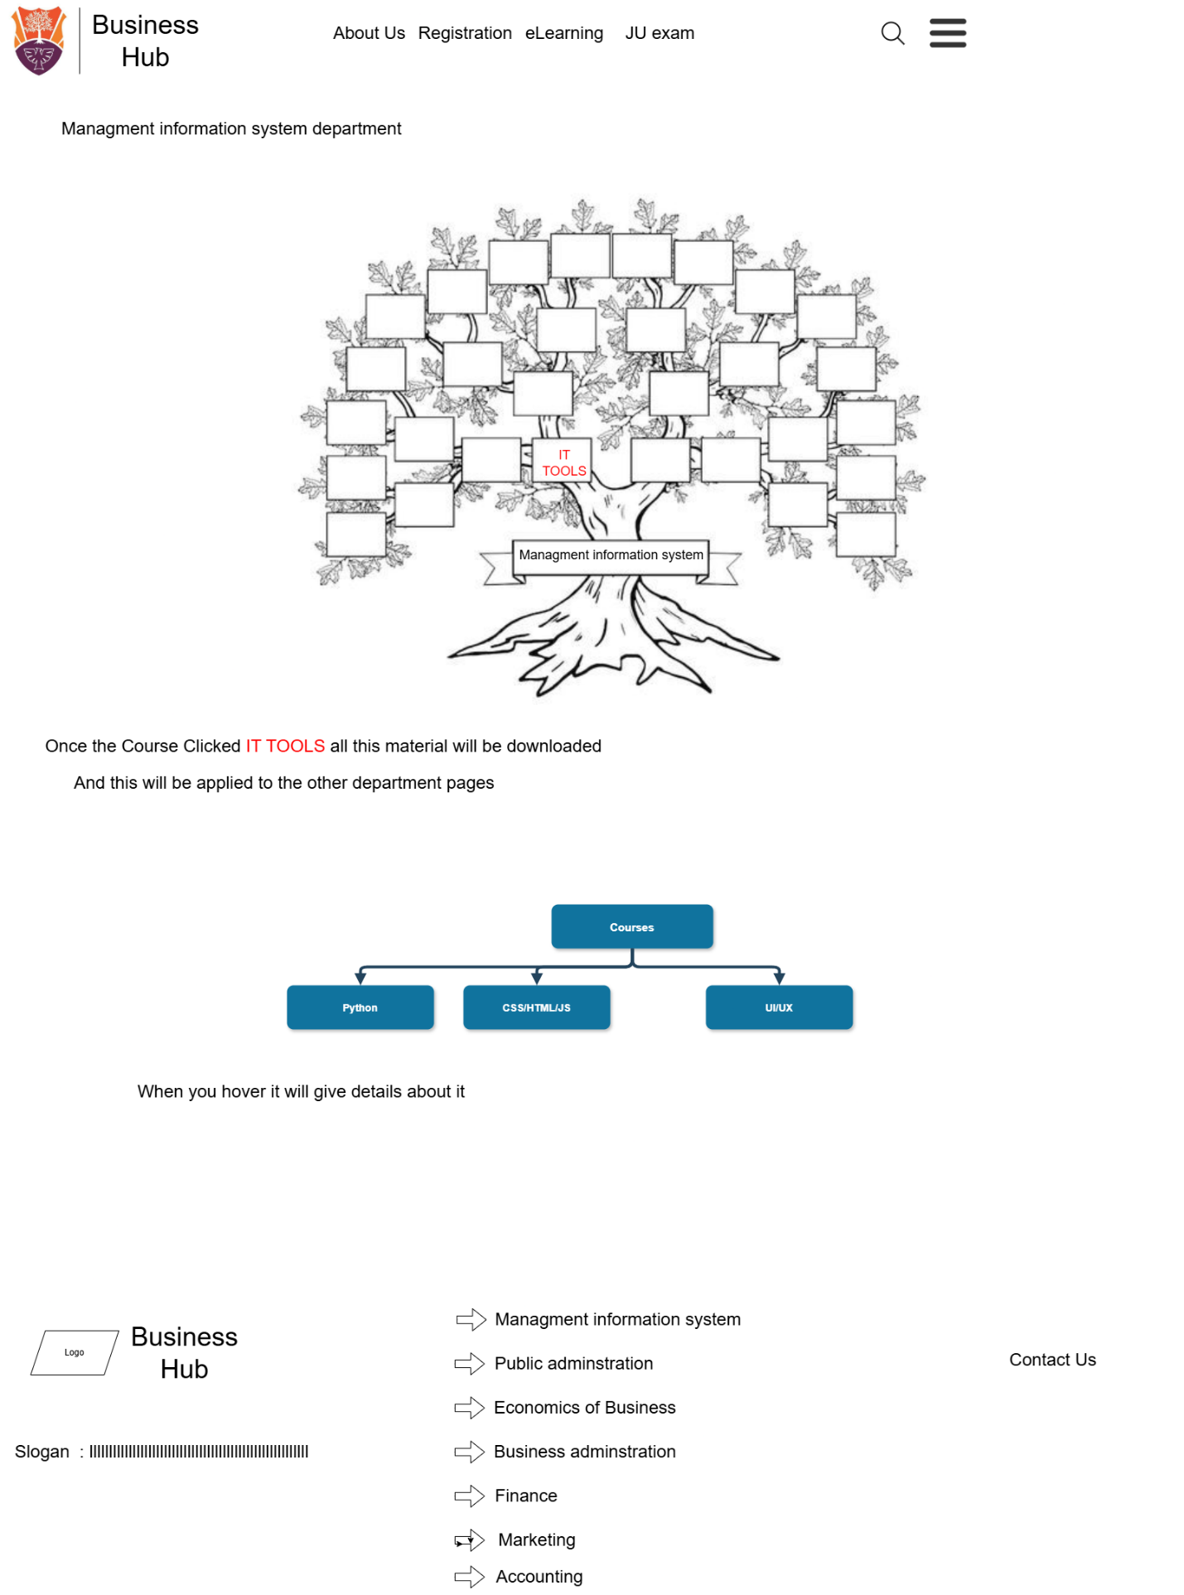

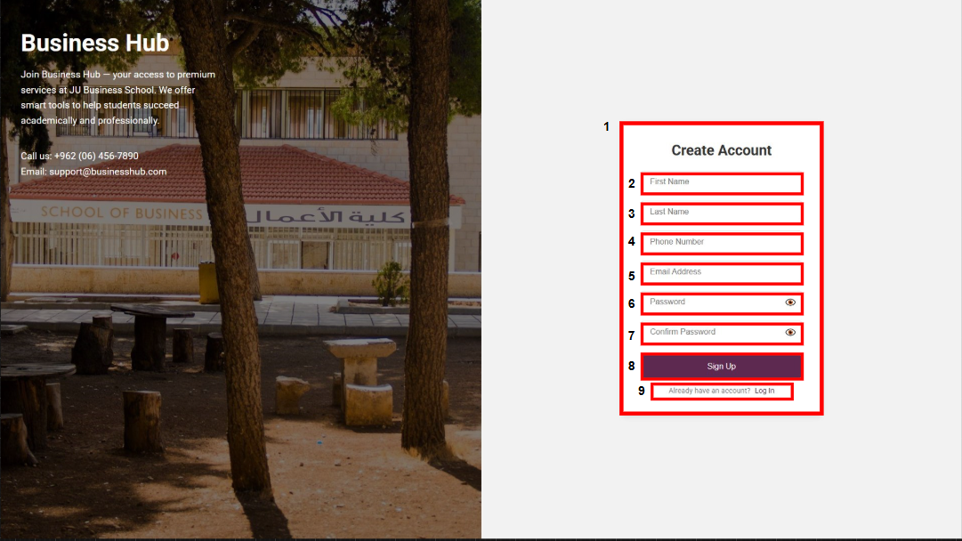

* 1. The registration page : and it’s contain the needed information to create an account .
  2. The First Name button : the user has to fill it .
  3. The Last Name button : the user has to fill it .
  4. The Phone Number button : the user has to fill it .
  5. The Email Address button : the user has to fill it .
  6. The Password button : the user has to fill it within the conditions and has the ability to view the password .
  7. The Confirm Password button : the user has to fill it and it needs to match the password that the user filled before conditions and has the ability to view the password .
  8. The Sign Up button : after the user fills the information above he/she suppose to click sign up to finish the process .
  9. The Log in button : if the user already has an account so it’s faster for him/her to sign in with this button .

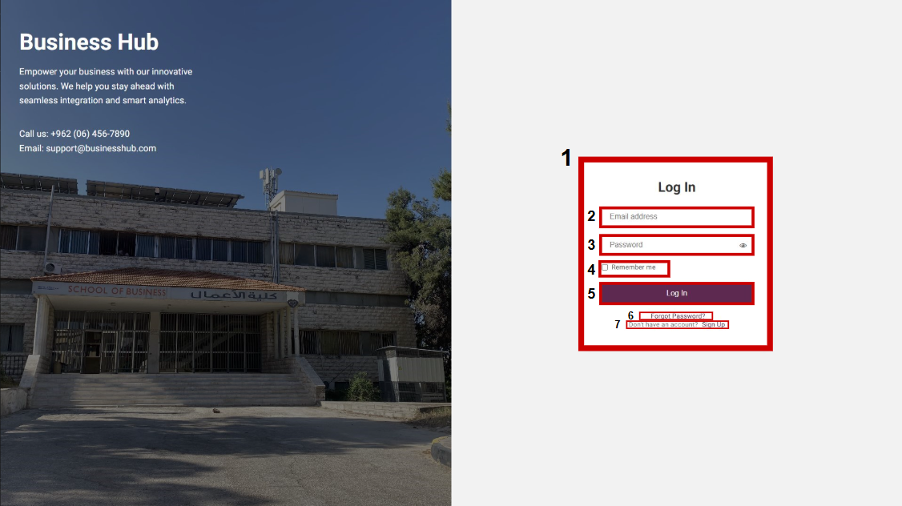

* + 1. The Log In form : and it’s contain the needed information to log in to your account .
    2. The Email Address button : the user has to fill it .
    3. The Password button : the user has to fill it within the conditions and has the ability to view the password .
    4. The Remember me button : helps the user to auto fill the information .
    5. The Log In button : after the user fills the information above he/she suppose to click log in to finish the process .
    6. The Forgot Password button : helps users to create new password .
    7. The Sign Up button : for users how don’t have an account yet .

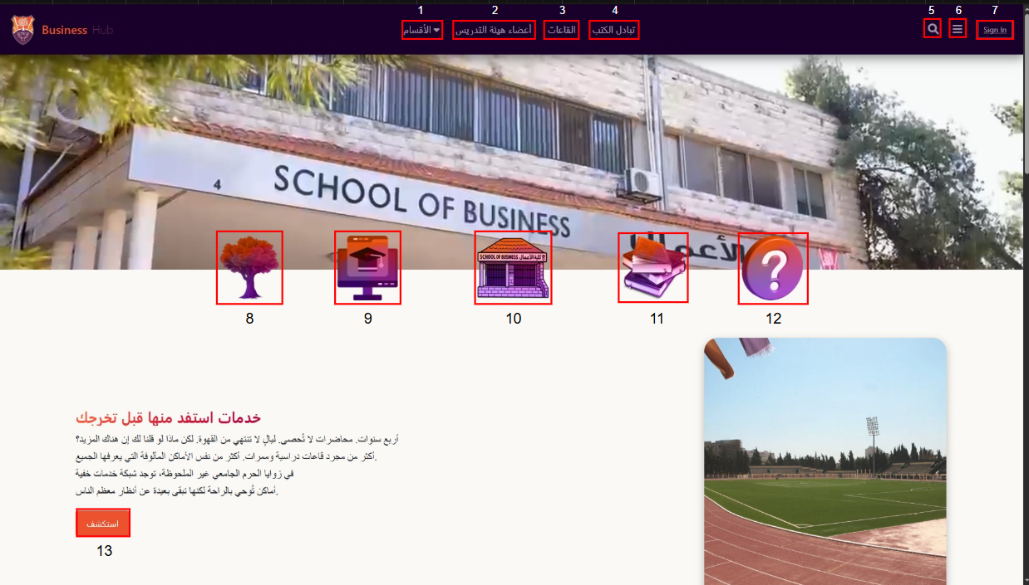

1. The ((الأقسام button : once the user hovers , it will show him/her the 7 majors .
2. The ((أعضاء هيئة التدريسbutton:once the user clicks , it will take him/her to the academic staff page .
3. The (القاعات) button : once the user clicks , it will take him/her to the halls page .
4. The (تبادل الكتب) button : once the user clicks , it will take him/her to the book exchange page .
5. The Search button : allows the user to search for anything in the website .
6. The Categories button : once the user clicks , it will slide down to show the user the services that we offer .
7. The Sign In button : applies the user to sign in and use the other features .
8. Once the user hovers it will show him/her the 7 majors , and take the user to the tree plan of his/her major .
9. Once the user hovers it will show him/her the 7 majors , and take the user to the courses supported for his/her major .
10. Once the user clicks , it will take him/her to the halls page .
11. Once the user clicks , it will take him/her to the book exchange page .
12. Once the user clicks , it will pop up for him/her and shows the FAQs .
13. The (استكشف) button : once the user clicks , it will take him/her to the Services Nearby .

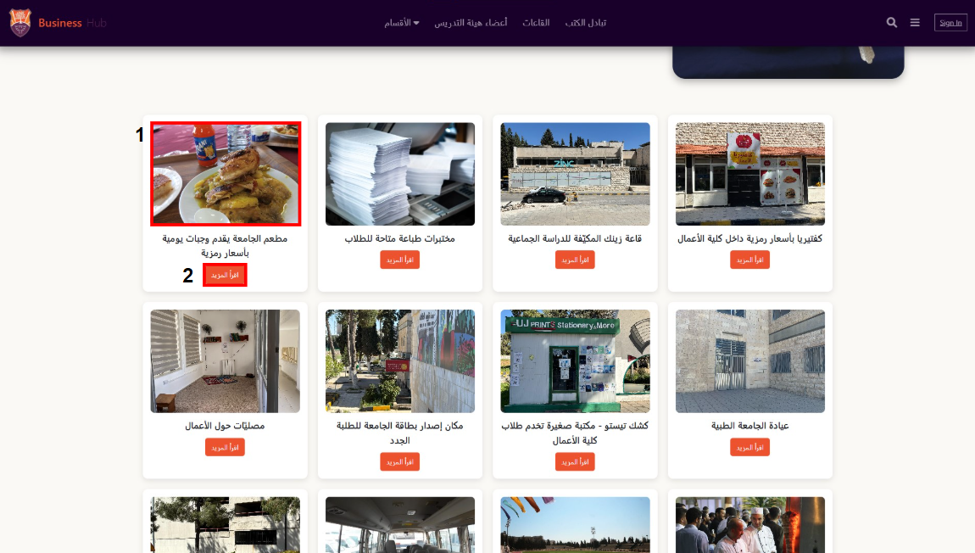

1. Slides of photos : once the user clicks , it will pop up and apply him/her to view the rest of the photos .
2. The (اقرأ المزيد) button : once the user clicks , it will give him/her a full description .

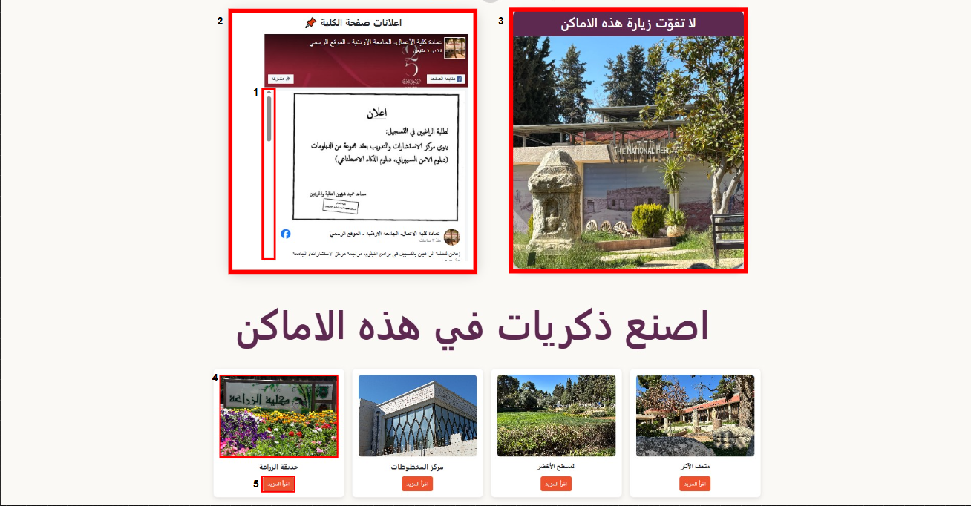

1. The Scroll Down feature .
2. Once the user clicks , it will take him/her to the main page .
3. once the user clicks , it will take him/her to the fun places .
4. Slides of photos : once the user clicks , it will pop up and apply him/her to view the rest of the photos .
5. The (اقرأ المزيد) button : once the user clicks , it will give him/her a full description .

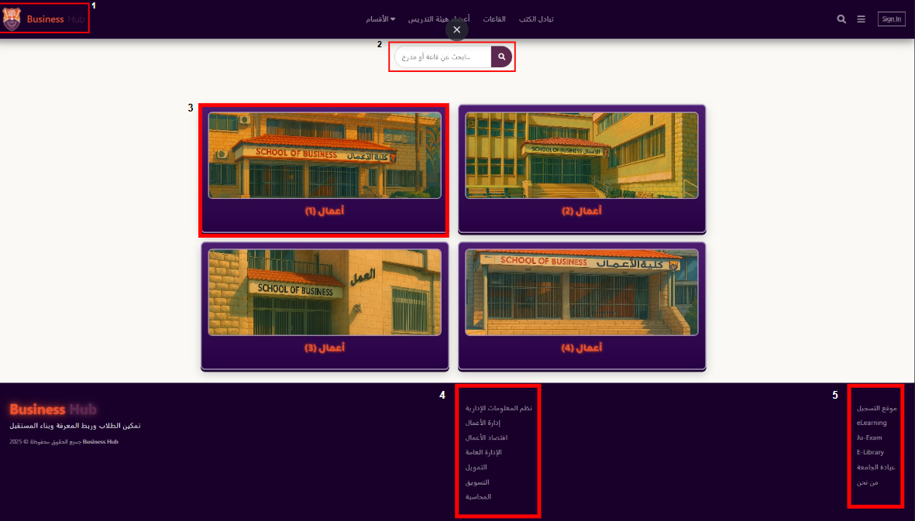

1. The Business Hub Logo : once the user clicks the logo , it will take him/her back to the main page .
2. The Search bar : the user is able to search for the hall that he/she is looking for .
3. Once the hovers on the card it will play a video for the school from the outside , and once he/she clicks it will show him/her a list of halls that the school has .
4. Once the user clicks on any of these majors , it will take the user to the chosen major page.
5. Once the user click on any of these sites , it will take the user to the chosen site main page .

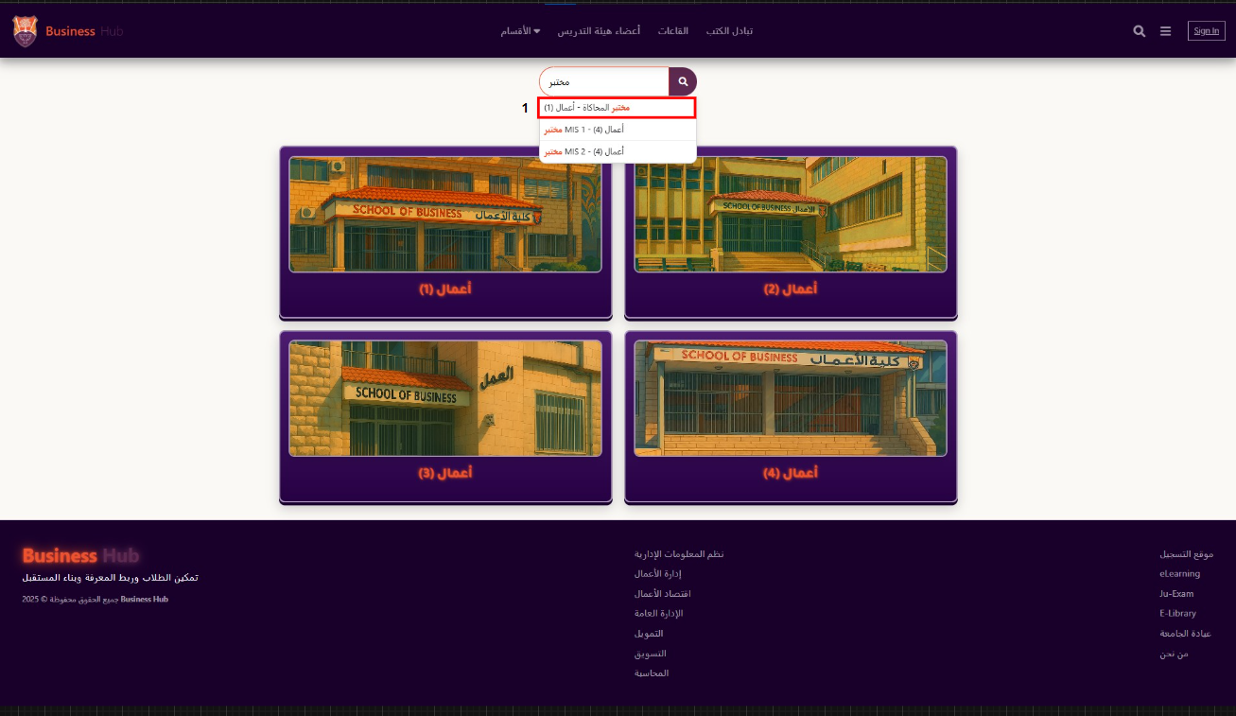

1. The filtering feature : To search for a specific hall among all buildings .

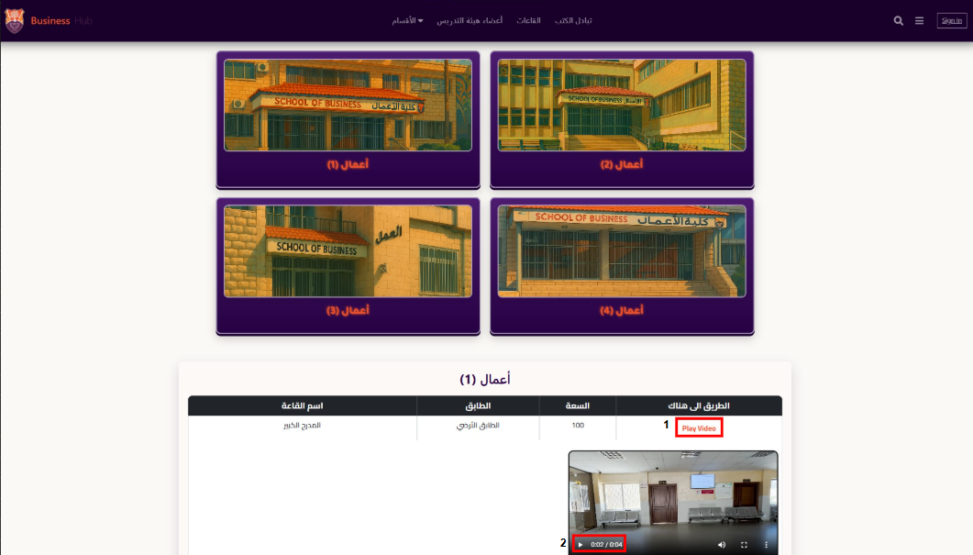

1. The Play video : once the user clicks . it will show him/her a video of the hall location .
2. It applies the user to stop and replay the video .

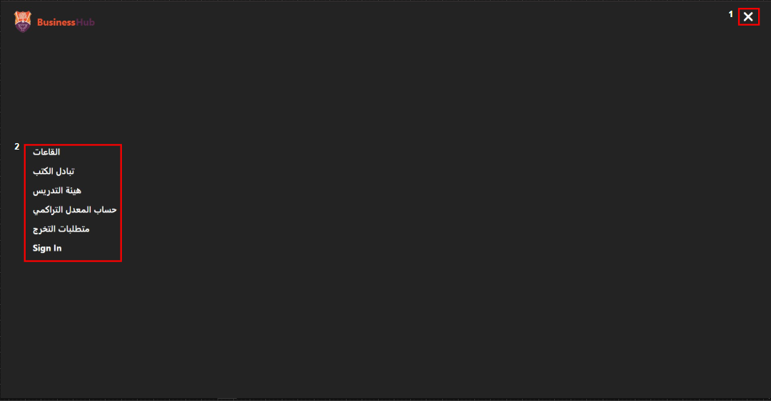

1. The (x) button : to close the category bar .
2. A list of the features that the website provide for the user , so when the user clicks on any feature , it will take him/her to the chosen feature page .

1-m 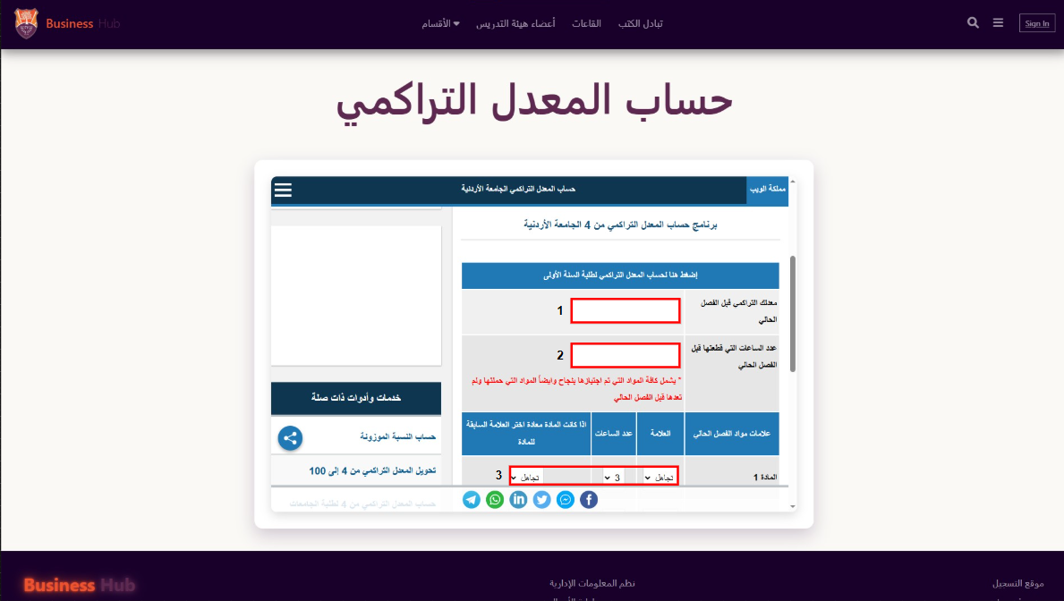

1. The user suppose to fill the field with the right numbers .
2. The user suppose to fill the field with the right numbers .
3. The user suppose to fill the fields with the right symbols and numbers .

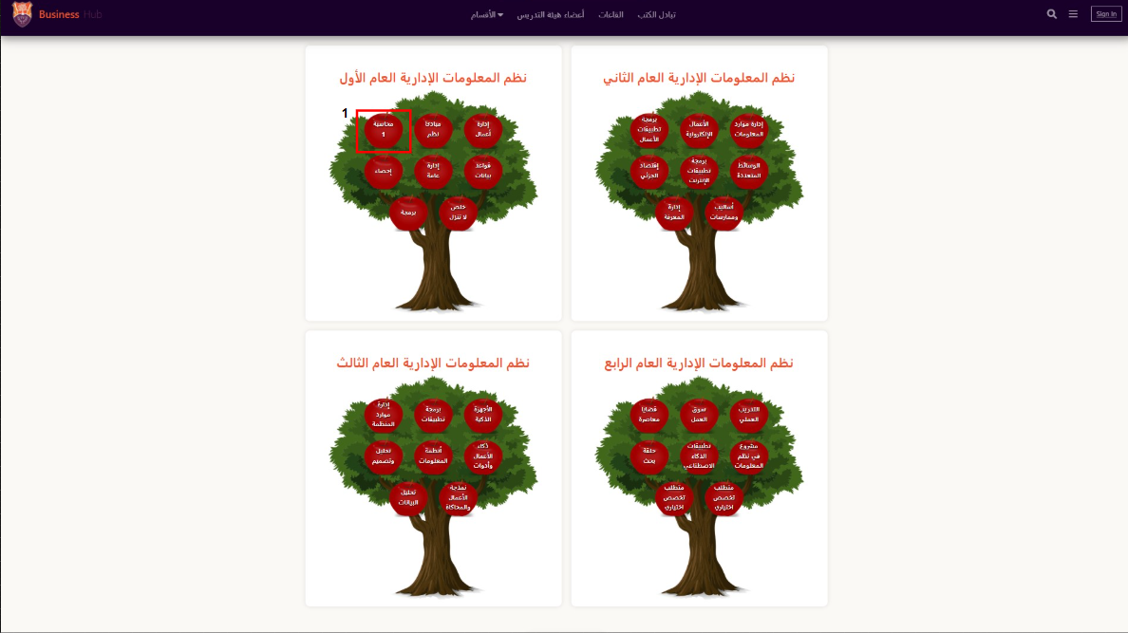

1. Once the user clicks on the material , it will take him/her to the book’s link and other things .

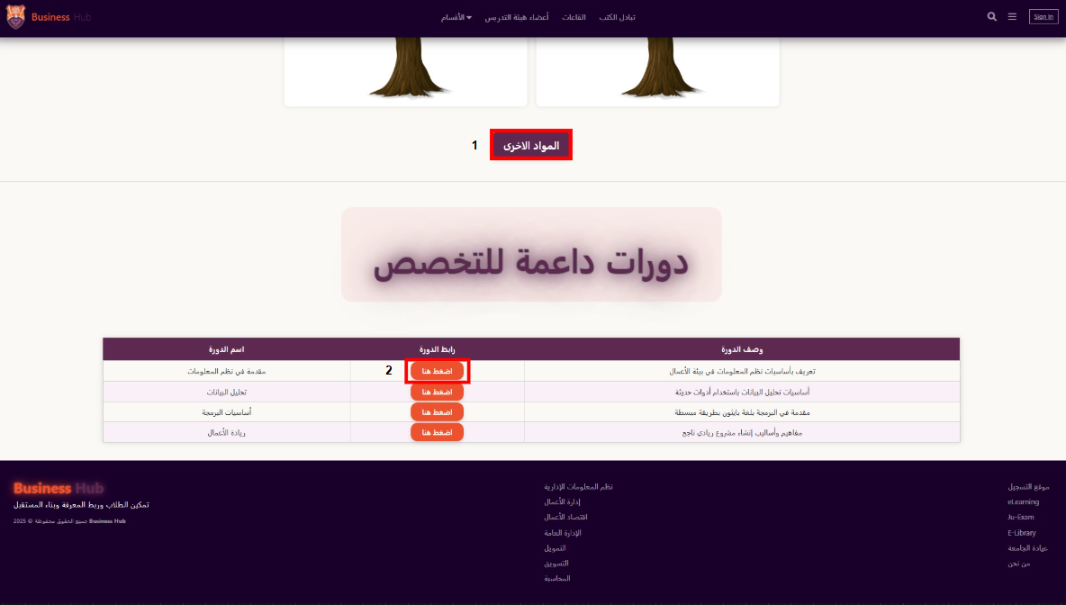

1. The (المواد الأخرى) button : enable the user to choose another material that’s not included in the tree .
2. The (اضغط هنا) button : once the user clicks it , it will take him/her to the course link .

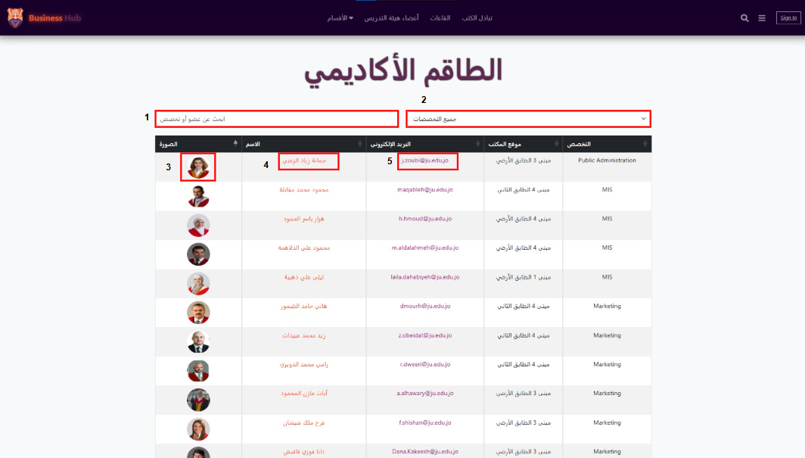

1. The ( ابحث عن عضو او تخصص) search bar : enable the user to search for the specific staff or major .
2. The (جميع التخصصات) drop down list : once the user clicks , it enables the user to choose a specific major.
3. Once the user clicks the photo , it will pop up for better view .
4. Once the user clicks on the name it will take him/her to the staff main page in the university website .
5. Once the user clicks , it will take him/her to the main teams email for the staff .

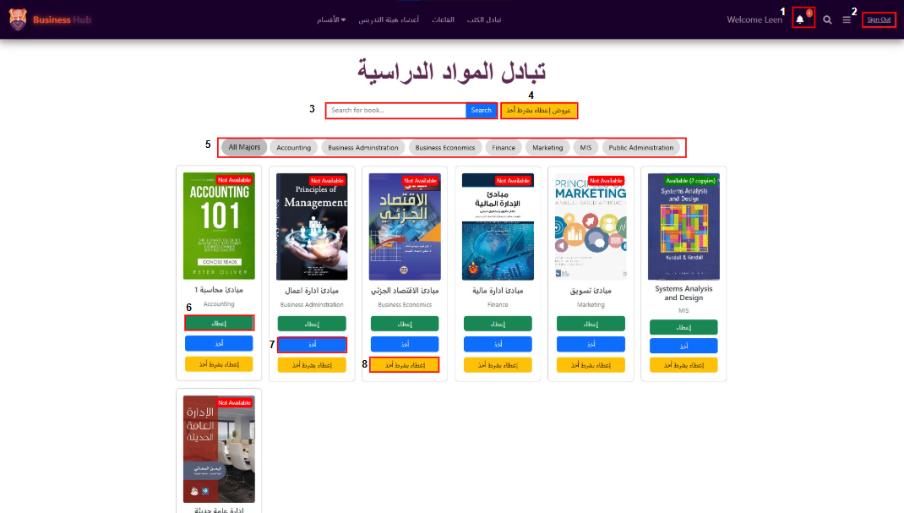

1. The notification center .
2. The Sign out button .
3. The search bar : enable the user to search for specific book .
4. The (عروض إعطاء مقابل أخذ) button : once the user clicks , it will show him/her in a panel a list of books for the exchange .
5. The majors buttons : filters the books based on the major that the user chose .
6. The (إعطاء) button : enables the user to put books for give .
7. The (أخذ) button : enable the user to take books from the giving .
8. The (إعطاء مقابل أخذ) button : enables users to exchange books between each other .

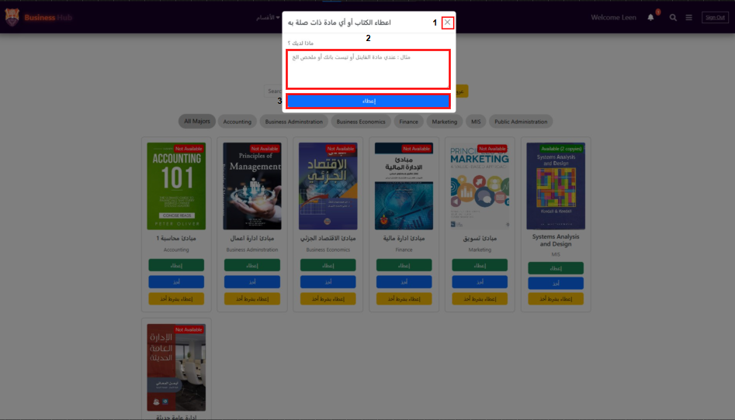

1. The (x) button : Once the user clicks it , it will close the panel .
2. The textbox : enables the user to fill the material details .
3. The (إعطاء) button : once the user clicks it , the book will be offered for other users .

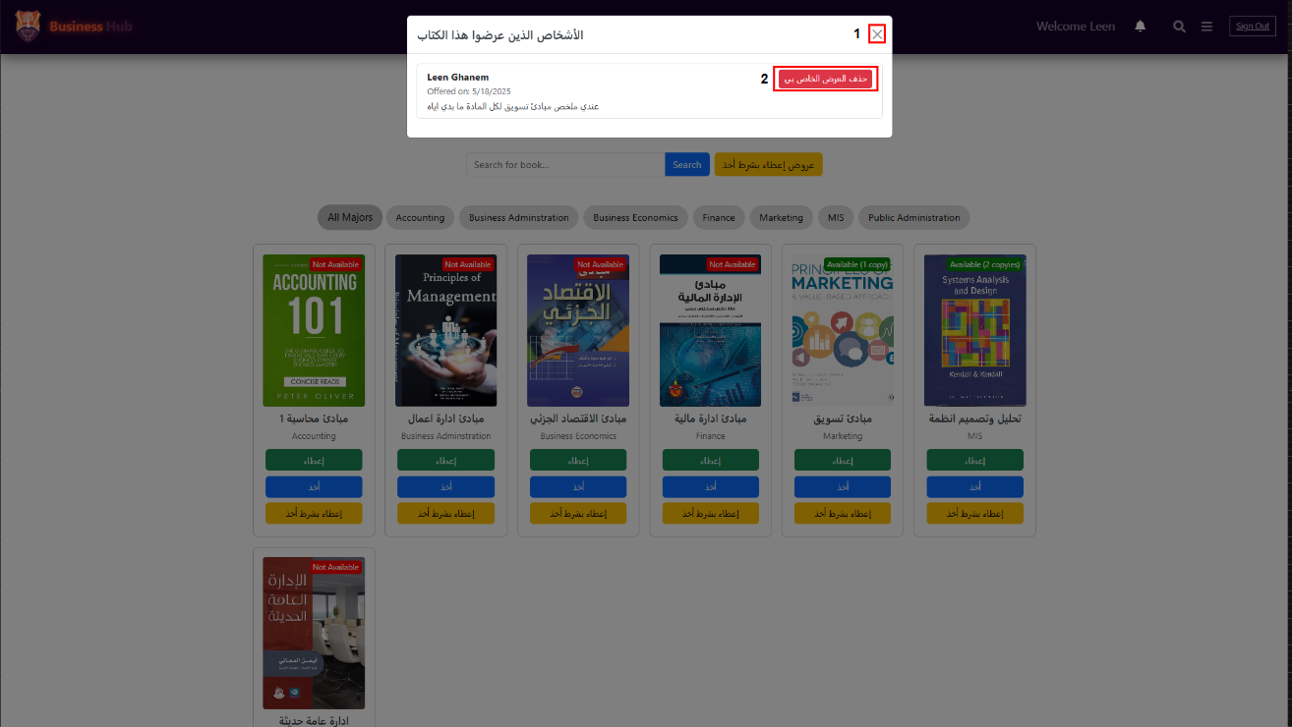

1. The (x) button : Once the user clicks it , it will close the panel .
2. The (حذف العرض الخاص بي) button : enables the giver to cancel the material offer .

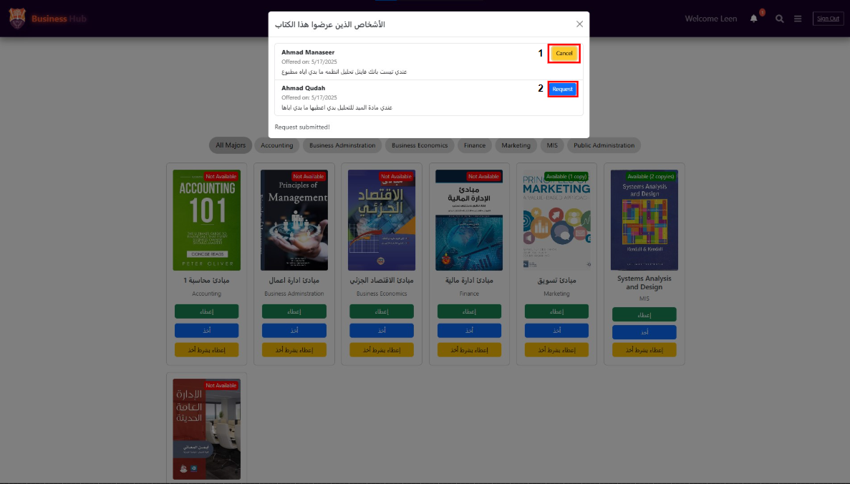

1. The (cancel) button : enables the user who wants to take a book to cancel the request .
2. The (Request) button : enables the user to make a request for the book that he/she needs .

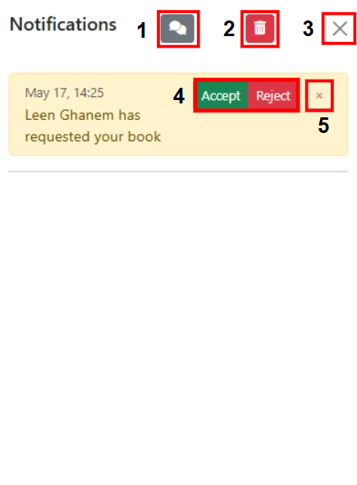

1. The chat button : enables a chat between the giver and the taker .
2. The delete button : enables the giver to delete all the notifications .
3. The (x) button : Once the user clicks it , it will close the panel .
4. The Accept/Reject buttons : enable the giver to choose the action .
5. The (x) button : Once the giver clicks it , it will remove the request .

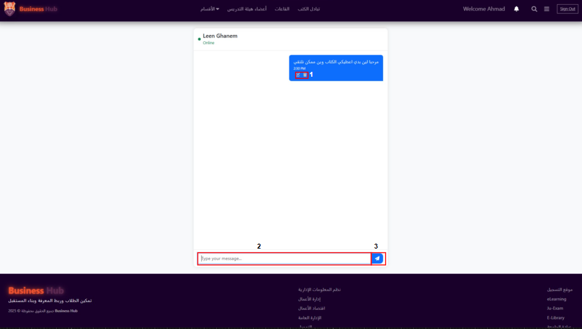

1. The Edit/Delete buttons : enable the sender to modify or delete the messages that has already sent .
2. The textbox : enable the user to write a message inside it .
3. The Send button : enables the user to send the message that he/she has been wrote .

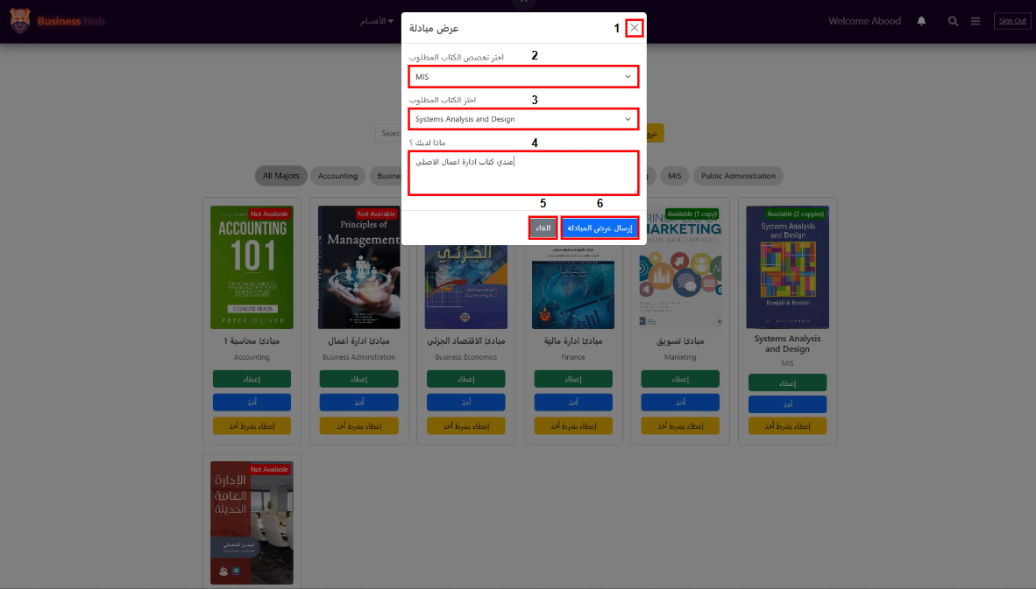

1. The (x) button : Once the user clicks it , it will close the panel .
2. The drop down list : enables the user to choose the material main major .
3. The drop down list : enables the user to choose the needed book for the exchange .
4. The textbox : enable the user to fill the material details .
5. The (الغاء) button : cancels the process .
6. The (إرسال عرض المبادلة) button : enables the user to submit the offer .

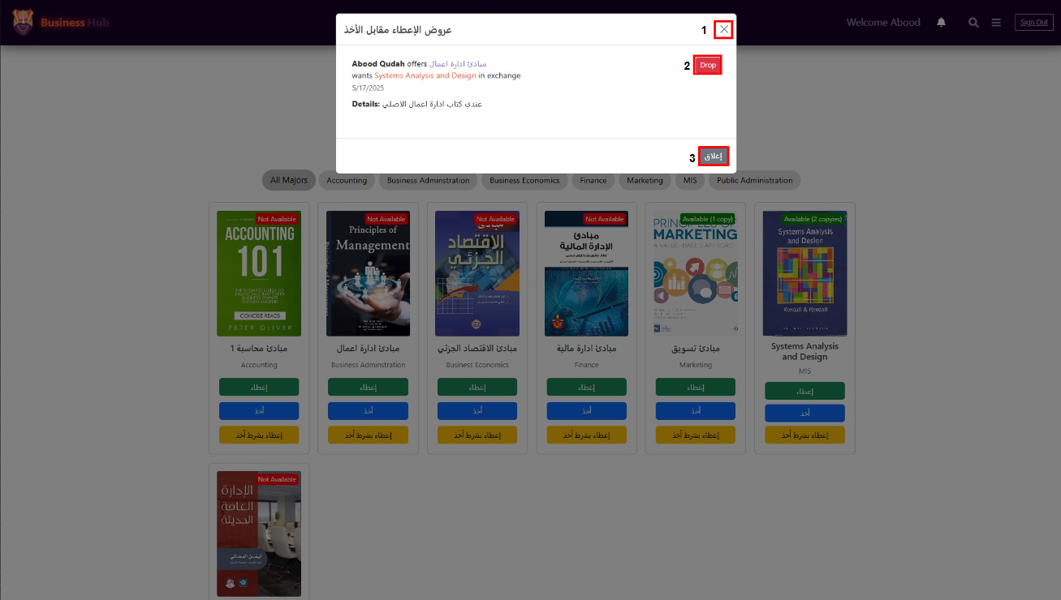

1. The (x) button : Once the user clicks it , it will close the panel .
2. The Drop button : the user can cancel the offer that has been submitted once he/she clicks on it .
3. The (إغلاق) button : once the user clicks , it will close the panel .

# Chapter 6

**Chapter 6: Conclusion**

This chapter provides a summary of the Business Hub system, highlights its significance, and discusses the main problem it aims to address. It also reflects on the work completed and presents possible directions for future development.

**Problem Statement**

University students at the Faculty of Business often face challenges in accessing essential resources, such as classroom locations, course materials, and information about academic staff. Finding the right hall, tracking down a specific teacher’s office, or exchanging study materials are common hurdles that can hinder a student’s academic experience and efficiency.

**Project Summary**

To address these issues, the Business Hub website was designed and implemented specifically for business students. The system brings together several key services in one unified platform:

* **Halls Location Page:**  
  Students can search for a specific hall by name or select from one of four business buildings. Upon selection, the system displays a detailed list of all halls in the chosen building, including each hall’s name, floor (stair), and a quick navigation video to help students find their way easily.
* **Department Pages:**  
  The platform includes seven department-specific pages, each structured by academic year (Year 1 to Year 4). These pages list the books and supporting materials required for each course, making it simple for students to access the resources relevant to their major.
* **Course Support:**  
  Within every department page, courses that support each major are clearly listed, helping students understand their study path and access supplementary resources.
* **Academic Staff Page:**  
  A dedicated page allows students to search for academic staff members by name, enabling quick access to information such as office locations and department affiliations.
* **Book Exchange:**  
  Business Hub also includes a book exchange feature, making it easy for students to offer and request textbooks or study materials, thus promoting sharing and reducing costs.

**Opportunities for Future Work**

While the initial implementation of Business Hub has addressed many pain points for business students, there are several opportunities for future enhancements:

* **Mobile Application:**  
  Developing a mobile version of the platform could make it even more accessible and convenient for students on the go.
* **Real-Time Navigation:**  
  Integrating real-time navigation or interactive campus maps could further simplify finding halls and offices.
* **Chat & Notifications:**  
  Adding a real-time chat system and personalized notifications for book exchanges, announcements, or staff office hours would increase engagement and usability.
* **Integration with University Systems:**  
  Connecting Business Hub to official university databases and authentication systems could automate data updates and improve security.

**Conclusion**

In summary, Business Hub is a significant step toward improving the academic experience of business students by centralizing key resources, simplifying everyday tasks, and fostering a sense of community through collaboration and sharing. With ongoing development and student feedback, the system can continue to evolve and address new needs in the future.